**TABLE OF CONTENTS**

|  |  |  |
| --- | --- | --- |
| **No.** | **Title** | **Page No.** |
| **1** | **Project Profile** | 03 |
|  | 1.1 Student Profile | 04 |
|  | 1.2 Project Definition | 05 |
| **2** | **Tools/ Platform** | 06 |
|  | 2.1 Front End Tools | 07 |
|  | 2.2 Back End Tools | 11 |
| **3** | **Analysis** | 14 |
|  | 3.1 About Existing System | 15 |
|  | 3.2 Advantages of proposed system | 17 |
|  | 3.3 Use case diagram | 18 |
|  | 3.4 DFD (Module wise) | 19 |
| **4** | **Design** | 20 |
|  | 4.1 E –R Diagram | 21 |
|  | 4.2 Class Diagram | 22 |
|  | 4.3 Activity Diagram | 23 |
|  | 4.4 Data Dictionary | 24 |
| **5** | **Testing and Implementation** | 28 |
|  | 5.1 Sample Code | 29 |
|  | 5.2 Screen Layout | 62 |
|  | 5.3 Testing | 75 |
| **6** | **Limitations and Future Enhancement** | 87 |
| **7** | **Bibliography** | 89 |

Chapter-1

PROJECT PROFILE

* 1. **Student Profile**
  2. **Project Definition**

|  |  |  |
| --- | --- | --- |
| Project Profile | | |
| next.jpg | **Enrollment No.** | 03052001105 |
| next.jpg | **Student Name** | Timbaliya Rahul  Mihir Vaddoriya  Manish Parmar |
| next.jpg | **Project Title** | Zoo Manageme System. |
| next.jpg | **Project Type** | Web Application |
| next.jpg | **Tools & Technology** | HTML,CSS,JAVA-SCRIPT PHP, MYSQL |
| next.jpg | **Front – End** | HTML,CSS,JAVA-SCRIPT |
| next.jpg | **Back – End** | PHP |
| next.jpg | **DataBase** | MYSQL |
| next.jpg | **Team Member** | 3 |

* 1. **Student Profile**

|  |  |  |
| --- | --- | --- |
| Name | **:** | Rahul Timbaliya |
| Enrolment No. | : | 03052001105 |
| Student Id. | : | 2020019120 |
| Mobile No: |  | 6353647592 |
| Email Id. | : | Rahultimbaliya555@gmail.com |
| Guided By | : | Prof. Pooja M.Pandya  Dr. Subhash College of Computer Science, Junagadh (362001) |
| Title of the Project Date of Submission | :  : | Zoo Management System  26.03.2022 |

* 1. **Student Profile**

|  |  |  |
| --- | --- | --- |
| Name | **:** | Mihir Vaddoriya |
| Enrolment No. | : | 3051900077 |
| Student Id. | : | 2020019121 |
| Mobile No |  |  |
| Email Id. | : | [urvashisurani995@gmail.com](mailto:urvashisurani995@gmail.com) |
| Guided By | : | Prof. Pooja M.Pandya  Dr. Subhash College of Computer Science, Junagadh (362001) |
| Title of the Project Date of Submission | :  : | Zoo Management System  26.03.2022 |

* 1. **Student Profile**

|  |  |  |
| --- | --- | --- |
| Name | **:** | Manish Parmar |
| Enrolment No. | : | 3051900077 |
| Student Id. | : | 2019009222 |
| Mobile No |  |  |
| Email Id. | : | [urvashisurani995@gmail.com](mailto:urvashisurani995@gmail.com) |
| Guided By | : | Prof. Pooja M.Pandya  Dr. Subhash College of Computer Science, Junagadh (362001) |
| Title of the Project Date of Submission | :  : | Zoo Management System  26.03.2022 |

**1.2 Project Definition :-**

* In two decades of operations in India, General Motors introduced the Opel and Chevrolet brands, but it was the latter that stuck around for the longest time.
* So, if you are a Chevrolet customer with a brand new model or an old one, your warranties will be honoured.
* The manufacturer has said that it is committed to maintaining a service network across key locations with trained staff to take care of all the needs of your Chevrolet car may it be for repair or maintenance.
* The company's dealerships will be shutting shop by the end of the year, but GM says its service centres will remain active.
* Several dealers that we spoke to across the country also iterated the same, stating that certain dealerships will continue to run the service centres, even if the display showroom is shut down.
* With regard to spares, GM India has assured that it will be making the components available even after the dealer network is shutdown.
* Please note that the Talegaon facility will continue to make all Chevrolet cars for export markets that are currently on sale in India, and it will also be producing most of the spares as needed.
* Moreover, the government mandates that car manufacturers make spares available of a vehicle for at least ten years after the model has been discontinued.
* So, like it has been for the old Hyundai Santro, Maruti Suzuki Ritz, or any of the recently discontinued models, spares will be available off the shelf.

Chapter-2

TOOLS / PLATFORM

* 1. **Front End Tools**
  2. **Back End Tools**
  3. **Database Tools**
  4. **Back End Tools**
* **PHP**
* **WHAT IS PHP :**



* PHP was developed by Rasmus Lerdorf . It is a freeware .
* It is also a weakly typed, freeform language.
* PHP has since evolved into a powerful server-side markup language with syntax that resembles a mix between Perl and C.
* PHP is a server-side scripting language designed specifically for the Web.
* Within an HTML page, we can embed PHP code that will be executed each time the page is visited.
* HTML generatesthe web page with the static text and images.
* However the need evolved for dynamic web basedapplication, mostly involving database usage. These dynamic usages are facilated by PHP.
* Other tasks that PHP is especially good at are database access,

 disk access, networking and textmanipulation.

* PHP is an excellent alternative to such similar programming solutions as Microsoft's proprietary scripting engine ASP and Allaire's rather expensive ColdFusion.
* As mentioned before,PHP is a cross-platform language.

**FEATURES OF PHP :**

* The main features of php is; it is open source scripting language so you can free download this and use.
* PHP is a server site scripting language. It is open source scripting language.
* It is widely used all over the world. It is faster than other scripting language. Some important features of php are given below;
* 

**History of PHP :**

* PHP was conceived sometime in the fall of 1994 by [Rasmus Lerdorf](mailto:rasmus@php.net).
* Early non-released versions were used on his home page to keep track of who was looking at his online resume.
* The first version used by others was available sometime in early 1995 and was known as the Personal Home Page Tools.
* It consisted of a very simplistic parser engine that only understood a few special macros and a number of utilities that were in common use on home pages back then.
* A guestbook, a counter and some other stuff. The parser was rewritten in mid-1995 and named PHP/FI Version 2.
* The FI came from another package Rasmus had written which interpreted html form data. He combined the Personal Home Page tools scripts with the Form Interpreter and added mSQL support and PHP/FI was born. PHP/FI grew at an amazing pace and people started contributing code to it.
* It is difficult to give any hard statistics, but it is estimated that by late 1996 PHP/FI was in use on at least 15,000 web sites around the world
* By mid-1997 this number had grown to over 50,000. Mid-1997 also saw a change in the development of PHP.
* It changed from being Rasmus' own pet project that a handful of people had contributed to, to being a much more organized team effort.
* The parser was rewritten from scratch by Zeev Suraski and Andi Gutmans and this new parser formed the basis for PHP Version 3.
* A lot of the utility code from PHP/FI was ported over to PHP3 and a lot of it was completely rewritten.
* Today (end-1999) either PHP/FI or PHP3 ships with a number of commercial products such as C2's StrongHold web server and RedHat Linux.
* A conservative estimate based on an extrapolation from numbers provided by [NetCraft](http://www.netcraft.com/) (see also [Netcraft Web Server Survey](http://www.netcraft.com/survey/)) would be that PHP is in use on over 1,000,000 sites around the world.
* To put that in perspective, that is more sites than run Netscape's flagship Enterprise server on the Internet.
* Also as of this writing, work is underway on the next generation of PHP, which will utilize the powerful [Zend](http://www.zend.com/) scripting engine to deliver higher performance, and will also support running under webservers other than Apache as a native server module.

.

* 1. **Datebase Tool**
* **MySQL**    

MySQL is currently the most popular database management system software used for managing the relational database. It is open-source database software, which is supported by Oracle Company. It is fast, scalable, and easy to use database management system in comparison with Microsoft SQL Server and Oracle Database. It is commonly used in conjunction with [PHP](https://www.javatpoint.com/php-tutorial) scripts for creating powerful and dynamic server-side or web-based enterprise applications.

It is developed, marketed, and supported by **MySQL AB, a Swedish company**, and written in [C programming language](https://www.javatpoint.com/c-programming-language-tutorial) and [C++ programming language](https://www.javatpoint.com/cpp-tutorial). The official pronunciation of MySQL is not the My Sequel; it is ***My Ess Que Ell***. However, you can pronounce it in your way. Many small and big comanies use MySQL. MySQL supports many Operating Systems like [Windows](https://www.javatpoint.com/windows), [Linux](https://www.javatpoint.com/linux-tutorial), MacOS, etc. with C, C++, and [Java languages](https://www.javatpoint.com/java-tutorial).

MySQL is a [Relational Database Management System](https://www.javatpoint.com/what-is-rdbms) (RDBMS) software that provides many things, which are as follows:

* It allows us to implement database operations on tables, rows, columns, and indexes.
* It defines the database relationship in the form of tables (collection of rows and columns), also known as relations.
* It provides the Referential Integrity between rows or columns of various tables.
* It allows us to updates the table indexes automatically.
* It uses many SQL queries and combines useful information from multiple tables for the end-users.

## History of MySQL:

The project of MySQL was started in 1979 when MySQL's inventor **Michael Widenius** developed an in-house database tool called **UNIREG** for managing databases. After that, UNIREG has been rewritten in several different languages and extended to handle big databases. After some time, Michael Widenius contacted **David Hughes**, the author of mSQL, to see if Hughes would be interested in connecting mSQL to UNIREG's B+ ISAM handler to provide indexing to mSQL. That's the way MySQL came into existence.

Chapter-3

ANALYSIS

**3.1 About Existing System**

**3.2 Advantages of proposed system**

**3.3 Use case diagram**

**3.4 DFD (Module wise)**

* 1. **Existing System :**
* Automobile is an emerging sector in India. With the influx of multinationals like SUZUI, HONDA,MAZDA, FORD,KAWASAKI, DAEWOO, MERCEDEZE, VESPA etc.
* In Indian Automobile Industry, a floor of various vehicles i.e. cars, motorcycles, scooters, tractors, & commercial vehicles with their different models and designs has come in the market.
* The automobile manufacturers mostly manufacture major parts of the vehicles themselves whereas various small & ancillary parts/components are procured from outside sources including ancillary units.
* The production of all the parts and components by any automobile manufacture may not be feasible and viable.
* It has been observed that a significant number of pins of various designs/specifications are used in almost each and every model of vehicle right from two wheelers to four wheelers and other special purpose/commercial vehicle.
* These pins may be the hub pins, valve pins, shaft pins, gear pins, suspension system pins, transmission system pins, cam pins, pump pins and gudgeon pins etc.
* The report deals with manufacture of various kinds of automobile pins.
* Today, as we drive our automobiles, a great many of us, can enjoy the same comfort levels that we are accustomed to at home and at work. With the push of a button or the slide of a lever, we make the seamless transition from heating to cooling and back again without ever wondering how this change occurs. That is, unless something goes awry.
* Since the advent of the automotive air conditioning system in the 1940's, many things have undergone extensive change. Improvements, such as computerized automatic temperature control (which allow you to set the desired temperature and have the system adjust automatically) and improvements to overall durability, have added complexity to today's modern air conditioning system. Unfortunately, the days of "do-it-yourself" repair to these systems, is almost a thing of the past
  1. **Advantages and Disadvantages**

**Advantages :**

* Providing direct information.
* Cancellation of any vehicle is provided.
* You can book any time 24*7.
* Filtering and searching.
* Availability checking.
* Booking: 1.Scheduling 2.Cancellation 3.Delivery
* Rent and Buy**.**

**Disadvantages :**

* Online payment is not available.
* Mandatory sign-up needed for the buyer.
* Only read module for viewer.
* Different rights for actors..
  1. **Use Case Diagram**

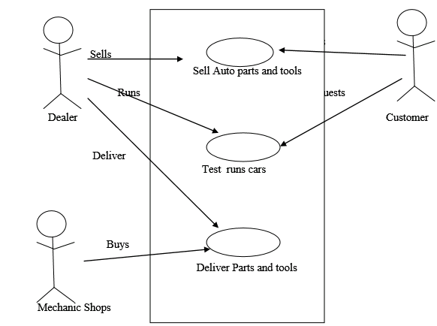

**3.5 Data Flow Diagram :**

Level 1 DFD :

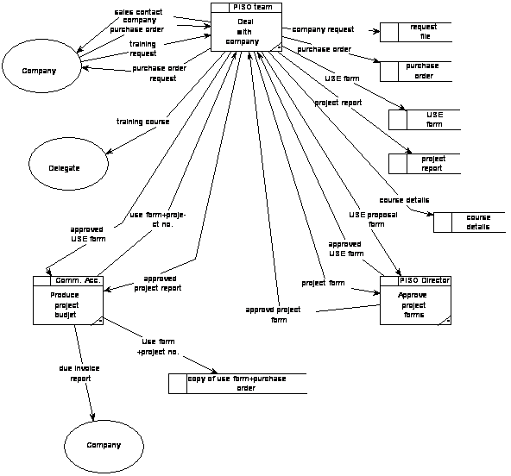

Chapter-4

DESIGN

**4.1 E –R Diagram**

**4.2 Class Diagram**

**4.3 Activity Diagram**

**4.4 Data Dictionary**

**4.1 E –R Diagram :**

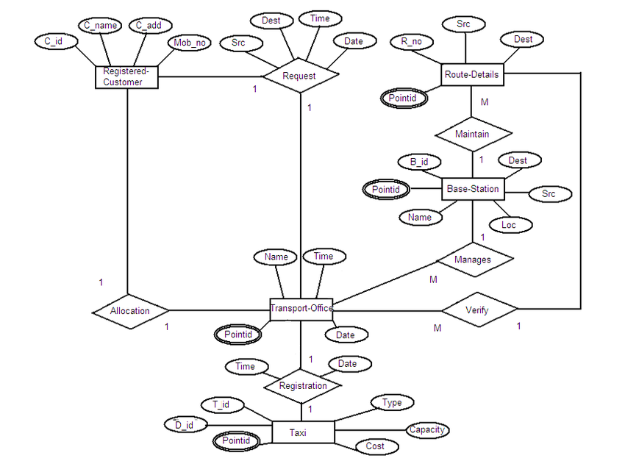

**4.2 Class Diagram :**

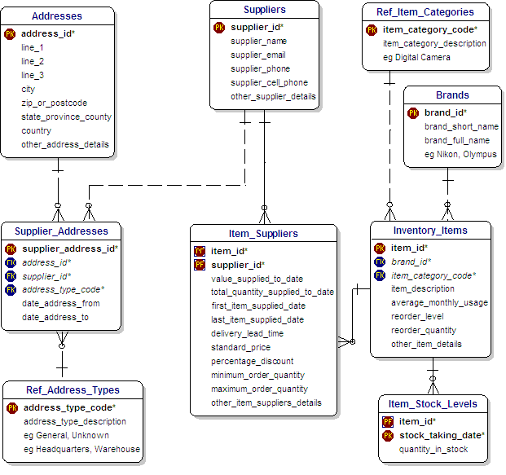

**4.3 Activity Diagram**

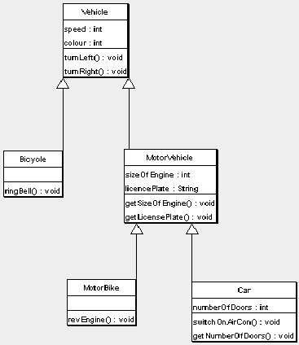

**4.4 Data Dictionary**

* **Addresses :**

|  |  |  |  |
| --- | --- | --- | --- |
| No | Name | Type | Not Null |
| 1 | Item_category_code | Integer | Primay key |
| 2 | Line1 | Varchar | - |
| 3 | Line2 | Varchar | - |
| 4 | Line3 | Varchar | - |
| 5 | city | Varchar | - |
| 6 | Post code | Varchar | - |
| 7 | Address | Varchar | - |
| 8 | City | Varchar | - |
| 9 | State province country | Varchar | - |
| 10 | Country | Varchar | - |
| 11 | Other address detail | Varchar | - |

* **Suppliers :**

|  |  |  |  |
| --- | --- | --- | --- |
| No | Name | Type | Not null |
| 1 | Supplier_Id | Integer | Primary key |
| 2 | Supplier_name | Varchar | - |
| 3 | Supplier_email | Varchar | - |
| 4 | Supplier_cell_phone | Varchar | - |
| 5 | Other_supplier_details | Varchar | - |

* **Ref_Item_category :**

|  |  |  |  |
| --- | --- | --- | --- |
| No | Name | Type | Not null |
| 1 | Id | Integer | Primarykey |
| 2 | Item_category_desc  (e.g.Digital Camera) | Varchar | - |

* **Ref_address_type :**

|  |  |  |  |
| --- | --- | --- | --- |
| No | Name | Type | Not null |
| 1 | Address_type_code | Integer | Primary key |
| 2 | Address_type_desc | Varchar | - |

* **Item Suppliers :**

|  |  |  |  |
| --- | --- | --- | --- |
| No | Name | Type | Not Null |
| 1 | Item_id | Integer | Primay key |
| 2 | Supplier_id | Varchar | - |
| 3 | Value_supplied_to_date | Date | - |
| 4 | Total_quantity_supply_to_date | Date | - |
| 5 | First_item_supply_date | Date | - |
| 6 | Last_item_supply_date | Date | - |
| 7 | Delivery_lead_time | Time | - |
| 8 | Standard_price | varchar | - |
| 9 | Percentage_discount | Varchar | - |
| 10 | Minimum_order_qty | Varchar | - |
| 11 | Maximum_order_qty | Varchar |  |
| 12 | Other item suppliers details | Varchar | - |

* **Supplier Addresses :**

|  |  |  |  |
| --- | --- | --- | --- |
| No | Name | Type | Not null |
| 1 | Supplier_address_id | Integer | Primary key |
| 2 | Address_id | Integer | Reference Key |
| 3 | Supplier_id | Integer | Foreign Key |
| 4 | Address_type_code | Varchar | - |
| 5 | Date_address_from | Date | - |
| 6 | Date_address_to | Date | - |

* **Brands :**

|  |  |  |  |
| --- | --- | --- | --- |
| No | Name | Type | Not null |
| 1 | Brand_id | Integer | Primary key |
| 2 | Brand_short_name | Varchar | - |
| 3 | Brand_full_name | Varchar |  |

Chapter-5

**Testing and Implementation**

**5.1 Sample Code**

**5.2 Screen Layout**

**5.3 Testing**

**5.1 Sample Code**

Here is the sample code of our project.

## index.php:

**<?php**

**include('includes/config.php');**

**?>**

**<!DOCTYPE HTML>**

**<html lang="en">**

**<head>**

**<meta http-equiv="Content-Type" content="text/html; charset=utf-8">**

**<meta http-equiv="X-UA-Compatible" content="IE=edge">**

**<meta name="viewport" content="width=device-width,initial-scale=1">**

**<meta name="keywords" content="">**

**<meta name="description" content="">**

**<title>DriveX Auto | Home Page</title>**

**<!--Bootstrap -->**

**<link rel="stylesheet" href="assets/css/bootstrap.min.css" type="text/css">**

**<link rel="stylesheet" href="assets/css/style.css" type="text/css">**

**<link rel="stylesheet" href="assets/css/owl.carousel.css" type="text/css">**

**<link rel="stylesheet" href="assets/css/owl.transitions.css" type="text/css">**

**<link href="assets/css/slick.css" rel="stylesheet">**

**<link href="assets/css/bootstrap-slider.min.css" rel="stylesheet">**

**<link href="assets/css/font-awesome.min.css" rel="stylesheet">**

**<link rel="stylesheet" id="switcher-css" type="text/css" href="assets/switcher/css/switcher.css" media="all" />**

**<link rel="alternate stylesheet" type="text/css" href="assets/switcher/css/red.css" title="red" media="all" data-default-color="true" />**

**<link rel="alternate stylesheet" type="text/css" href="assets/switcher/css/orange.css" title="orange" media="all" />**

**<link rel="alternate stylesheet" type="text/css" href="assets/switcher/css/blue.css" title="blue" media="all" />**

**<link rel="alternate stylesheet" type="text/css" href="assets/switcher/css/pink.css" title="pink" media="all" />**

**<link rel="alternate stylesheet" type="text/css" href="assets/switcher/css/green.css" title="green" media="all" />**

**<link rel="alternate stylesheet" type="text/css" href="assets/switcher/css/purple.css" title="purple" media="all" />**

**<link rel="apple-touch-icon-precomposed" sizes="144x144" href="assets/images/favicon-icon/apple-touch-icon-144-precomposed.png">**

**<link rel="apple-touch-icon-precomposed" sizes="114x114" href="assets/images/favicon-icon/apple-touch-icon-114-precomposed.html">**

**<link rel="apple-touch-icon-precomposed" sizes="72x72" href="assets/images/favicon-icon/apple-touch-icon-72-precomposed.png">**

**<link rel="apple-touch-icon-precomposed" href="assets/images/favicon-icon/apple-touch-icon-57-precomposed.png">**

**<link rel="shortcut icon" href="assets/images/favicon-icon/favicon1.png">**

**<link href="https://fonts.googleapis.com/css?family=Lato:300,400,700,900" rel="stylesheet">**

**</head>**

**<body>**

**<!-- Start Switcher -->**

**<!-- <?php include('includes/colorswitcher.php');?> -->**

**<!-- /Switcher -->**

**<!--Header-->**

**<?php include('includes/header.php');?>**

**<!-- /Header -->**

**<!-- Banners -->**

**<section id="banner" class="banner-section" style="background-image: url('assets/images/banner.jpg')">**

**<div class="container">**

**<div class="div_zindex">**

**<div class="row">**

**<div class="col-md-5 col-md-push-11">**

**<div class="banner_content">**

**<!-- <img src="assets/images/banner.jpg"> -->**

**<h1>Find The car for rent and sell</h1>**

**<p>We have list of varieties for cars and automobile parts.</p>**

**</div>**

**</div>**

**</div>**

**</div>**

**</section>**

**<!-- /Banners -->**

**<!-- Resent Cat-->**

**<section class="section-padding gray-bg">**

**<div class="container">**

**<div class="section-header text-center">**

**<h2><span>Find the List of Cars </span>For Rent and Sell</h2>**

**<p>Car Listing...</p>**

**</div>**

**</div>**

**</section>**

**<!-- /Resent Cat -->**

**<!-- Fun Facts-->**

**<!-- /Fun Facts-->**

**<!--Testimonial -->**

**<section class="section-padding testimonial-section parallex-bg" style="background-image: url(assets/images/recent-car-6.jpg);">**

**<div class="container div_zindex">**

**<div class="section-header white-text text-center">**

**<h2>Our Satisfied <span>Customers</span></h2>**

**</div>**

**<div class="row">**

**<div id="testimonial-slider">**

**<?php**

**//$tid=1;**

**$sql = "SELECT * FROM tblusers WHERE user_type = '' ";**

**$query = mysqli_query($conn,$sql);**

**//$results = mysqli_fetch_array($query);**

**//$cnt=1;**

**if(mysqli_num_rows($query) > 0)**

**{**

**while($result = mysqli_fetch_array($query))**

**{**

**?>**

**<div class="testimonial-m">**

**<div class="testimonial-img" style="padding-bottom: 100px;"> <img src="assets/images/User_Avatar_2.png" alt="cta" /> </div>**

**<div class="testimonial-content">**

**<div class="testimonial-heading">**

**<h5><?php echo $result['FullName'];?></h5>**

**<p>Easy to book a car for rent.</p>**

**<p>Great Work!</p>**

**<p>Car for sale is also important feature.</p>**

**</div>**

**</div>**

**</div>**

**<?php }} ?>**

**</div>**

**</div>**

**</div>**

**<!-- Dark Overlay-->**

**<div class="dark-overlay"></div>**

**</section>**

**<!-- /Testimonial-->**

**<!--Footer -->**

**<?php include('includes/footer.php');?>**

**<!-- /Footer-->**

**<!--Back to top-->**

**<div id="back-top" class="back-top"> <a href="#top"><i class="fa fa-angle-up" aria-hidden="true"></i> </a> </div>**

**<!--/Back to top-->**

**<!--Login-Form -->**

**<?php include('includes/login.php');?>**

**<!--/Login-Form -->**

**<!--Register-Form -->**

**<?php include('includes/registration.php');?>**

**<!--/Register-Form -->**

**<!--Forgot-password-Form -->**

**<?php include('includes/forgotpassword.php');?>**

**<!--/Forgot-password-Form -->**

**<!-- Scripts -->**

**<script src="assets/js/jquery.min.js"></script>**

**<script src="assets/js/bootstrap.min.js"></script>**

**<script src="assets/js/interface.js"></script>**

**<!--Switcher-->**

**<script src="assets/switcher/js/switcher.js"></script>**

**<!--bootstrap-slider-JS-->**

**<script src="assets/js/bootstrap-slider.min.js"></script>**

**<!--Slider-JS-->**

**<script src="assets/js/slick.min.js"></script>**

**<script src="assets/js/owl.carousel.min.js"></script>**

**</body>**

**</html>**

## login.php:

**<?php**

**include('includes/config.php');**

**if(isset($_POST['username']) && isset($_POST['password']))**

**{**

**$username=$_POST['username'];**

**$password=md5($_POST['password']);**

**//echo $username." ".$password;**

**$sql="SELECT * FROM tblusers WHERE Username = '$username' AND Password = '$password'**

**AND user_type = 'Buyer' OR user_type = 'User' AND status = '1' ";**

**$query = mysqli_query($conn,$sql);**

**if(mysqli_num_rows($query) > 0)**

**{**

**while($row = mysqli_fetch_array($query))**

**{**

**$_SESSION['username']=$row['Username'];**

**$_SESSION['id']=$row['id'];**

**header("Location: car_rent_sale.php");**

**}**

**}**

**else**

**{**

**/*echo "<script>alert('Invalid Details');</script>";*/**

**}**

**}**

**?>**

**<!doctype html>**

**<html lang="en" class="no-js">**

**<head>**

**<meta charset="UTF-8">**

**<meta http-equiv="X-UA-Compatible" content="IE=edge">**

**<meta name="viewport" content="width=device-width, initial-scale=1, minimum-scale=1, maximum-scale=1">**

**<meta name="description" content="">**

**<meta name="author" content="">**

**<title>DriveX Auto | Dealer Login</title>**

**<link rel="stylesheet" href="css/font-awesome.min.css">**

**<link rel="stylesheet" href="css/bootstrap.min.css">**

**<link rel="stylesheet" href="css/dataTables.bootstrap.min.css">**

**<link rel="stylesheet" href="css/bootstrap-social.css">**

**<link rel="stylesheet" href="css/bootstrap-select.css">**

**<link rel="stylesheet" href="css/fileinput.min.css">**

**<link rel="stylesheet" href="css/awesome-bootstrap-checkbox.css">**

**<link rel="stylesheet" href="css/style.css">**

**<link rel="shortcut icon" href="../admin/img/favicon1.png">**

**</head>**

**<body>**

**<div class="login-page bk-img" style="background-image: url(img/ad-login-bg.jpg);">**

**<div class="form-content">**

**<div class="container">**

**<div class="row">**

**<div class="col-md-6 col-md-offset-3">**

**<h1 class="text-center text-bold text-light mt-4x" style="font-size: 50px;">Sign in</h1>**

**<div class="well row pt-2x pb-3x bk-light">**

**<div class="col-md-8 col-md-offset-2">**

**<form method="post">**

**<label for="" class="text-uppercase text-sm">Your Userhgjname </label>**

**<input type="text" placeholder="Username" name="username" class="form-control mb">**

**<label for="" class="text-uppercase text-sm">Password</label>**

**<input type="password" placeholder="Password" name="password" class="form-control mb">**

**<button class="btn btn-primary btn-block" name="login" type="submit" style="font-size: 20px;">LOGIN</button>**

**</form>**

**</div>**

**</div>**

**<a href="../index.php"><button class="btn btn-primary btn-block btn-xs uppercase" style="height: 30px; font-size: 18px;">Back to Home</button></a>**

**</div>**

**</div>**

**</div>**

**</div>**

**</div>**

**<!-- Loading Scripts -->**

**<script src="js/jquery.min.js"></script>**

**<script src="js/bootstrap-select.min.js"></script>**

**<script src="js/bootstrap.min.js"></script>**

**<script src="js/jquery.dataTables.min.js"></script>**

**<script src="js/dataTables.bootstrap.min.js"></script>**

**<script src="js/Chart.min.js"></script>**

**<script src="js/fileinput.js"></script>**

**<script src="js/chartData.js"></script>**

**<script src="js/main.js"></script>**

**</body>**

**</html>**

## logout.php:

**<?php**

**session_start();**

**$_SESSION = array();**

**if (ini_get("session.use_cookies")) {**

**$params = session_get_cookie_params();**

**setcookie(session_name(), '', time() - 60*60,**

**$params["path"], $params["domain"],**

**$params["secure"], $params["httponly"]**

**);**

**}**

**unset($_SESSION['login']);**

**session_destroy(); // destroy session**

**header("location:index.php");**

**?>**

## profile.php:

**<?php**

**session_start();**

**//error_reporting(0);**

**include('includes/config.php');**

**if(strlen($_SESSION['login'])==0)**

**{**

**header('location:index.php');**

**}**

**else{**

**if(isset($_POST['updateprofile']))**

**{**

**$name=$_POST['fullname'];**

**$mobileno=$_POST['mobilenumber'];**

**$dob=$_POST['dob'];**

**$adress=$_POST['address'];**

**$city=$_POST['city'];**

**$pincode = $_POST['pincode'];**

**$email=$_SESSION['login'];**

**$sql="update tblusers set FullName=:name,ContactNo=:mobileno,dob=:dob,Address=:adress,City=:city,pincode=:pincode where EmailId=:email";**

**$query = $dbh->prepare($sql);**

**$query->bindParam(':name',$name,PDO::PARAM_STR);**

**$query->bindParam(':mobileno',$mobileno,PDO::PARAM_STR);**

**$query->bindParam(':dob',$dob,PDO::PARAM_STR);**

**$query->bindParam(':adress',$adress,PDO::PARAM_STR);**

**$query->bindParam(':city',$city,PDO::PARAM_STR);**

**$query->bindParam(':pincode',$pincode,PDO::PARAM_STR);**

**$query->bindParam(':email',$email,PDO::PARAM_STR);**

**$query->execute();**

**$msg="Profile Updated Successfully";**

**}**

**?>**

**<!DOCTYPE HTML>**

**<html lang="en">**

**<head>**

**<meta http-equiv="Content-Type" content="text/html; charset=utf-8">**

**<meta http-equiv="X-UA-Compatible" content="IE=edge">**

**<meta name="viewport" content="width=device-width,initial-scale=1">**

**<meta name="keywords" content="">**

**<meta name="description" content="">**

**<title>DriveX Auto | My Profile</title>**

**<!--Bootstrap -->**

**<link rel="stylesheet" href="assets/css/bootstrap.min.css" type="text/css">**

**<!--Custome Style -->**

**<link rel="stylesheet" href="assets/css/style.css" type="text/css">**

**<!--OWL Carousel slider-->**

**<link rel="stylesheet" href="assets/css/owl.carousel.css" type="text/css">**

**<link rel="stylesheet" href="assets/css/owl.transitions.css" type="text/css">**

**<!--slick-slider -->**

**<link href="assets/css/slick.css" rel="stylesheet">**

**<!--bootstrap-slider -->**

**<link href="assets/css/bootstrap-slider.min.css" rel="stylesheet">**

**<!--FontAwesome Font Style -->**

**<link href="assets/css/font-awesome.min.css" rel="stylesheet">**

**<!-- SWITCHER -->**

**<link rel="stylesheet" id="switcher-css" type="text/css" href="assets/switcher/css/switcher.css" media="all" />**

**<link rel="alternate stylesheet" type="text/css" href="assets/switcher/css/red.css" title="red" media="all" data-default-color="true" />**

**<link rel="alternate stylesheet" type="text/css" href="assets/switcher/css/orange.css" title="orange" media="all" />**

**<link rel="alternate stylesheet" type="text/css" href="assets/switcher/css/blue.css" title="blue" media="all" />**

**<link rel="alternate stylesheet" type="text/css" href="assets/switcher/css/pink.css" title="pink" media="all" />**

**<link rel="alternate stylesheet" type="text/css" href="assets/switcher/css/green.css" title="green" media="all" />**

**<link rel="alternate stylesheet" type="text/css" href="assets/switcher/css/purple.css" title="purple" media="all" />**

**<link rel="apple-touch-icon-precomposed" sizes="144x144" href="assets/images/favicon-icon/apple-touch-icon-144-precomposed.png">**

**<link rel="apple-touch-icon-precomposed" sizes="114x114" href="assets/images/favicon-icon/apple-touch-icon-114-precomposed.html">**

**<link rel="apple-touch-icon-precomposed" sizes="72x72" href="assets/images/favicon-icon/apple-touch-icon-72-precomposed.png">**

**<link rel="apple-touch-icon-precomposed" href="assets/images/favicon-icon/apple-touch-icon-57-precomposed.png">**

**<link rel="shortcut icon" href="assets/images/favicon-icon/favicon1.png">**

**<link href="https://fonts.googleapis.com/css?family=Lato:300,400,700,900" rel="stylesheet">**

**<!-- Bootstrap Date-Picker Plugin -->**

**<link rel="stylesheet" href="https://cdnjs.cloudflare.com/ajax/libs/bootstrap-datepicker/1.4.1/css/bootstrap-datepicker3.css"/>**

**<style>**

**.errorWrap {**

**padding: 10px;**

**margin: 0 0 20px 0;**

**background: #fff;**

**border-left: 4px solid #dd3d36;**

**-webkit-box-shadow: 0 1px 1px 0 rgba(0,0,0,.1);**

**box-shadow: 0 1px 1px 0 rgba(0,0,0,.1);**

**}**

**.succWrap{**

**padding: 10px;**

**margin: 0 0 20px 0;**

**background: #fff;**

**border-left: 4px solid #5cb85c;**

**-webkit-box-shadow: 0 1px 1px 0 rgba(0,0,0,.1);**

**box-shadow: 0 1px 1px 0 rgba(0,0,0,.1);**

**}**

**</style>**

**</head>**

**<body>**

**<!-- Start Switcher -->**

**<!-- /Switcher -->**

**<!--Header-->**

**<?php include('includes/header.php');?>**

**<!-- /Header -->**

**<!--Page Header-->**

**<section class="page-header profile_page">**

**<div class="container">**

**<div class="page-header_wrap">**

**<div class="page-heading">**

**<h1>Your Profile</h1>**

**</div>**

**<ul class="coustom-breadcrumb">**

**<li><a href="#">Home</a></li>**

**<li>Profile</li>**

**</ul>**

**</div>**

**</div>**

**<!-- Dark Overlay-->**

**<div class="dark-overlay"></div>**

**</section>**

**<!-- /Page Header-->**

**<?php**

**$useremail=$_SESSION['login'];**

**$sql = "SELECT * from tblusers where EmailId=:useremail";**

**$query = $dbh -> prepare($sql);**

**$query -> bindParam(':useremail',$useremail, PDO::PARAM_STR);**

**$query->execute();**

**$results=$query->fetchAll(PDO::FETCH_OBJ);**

**$cnt=1;**

**if($query->rowCount() > 0)**

**{**

**foreach($results as $result)**

**{ ?>**

**<section class="user_profile inner_pages">**

**<div class="container">**

**<div class="user_profile_info gray-bg padding_4x4_40">**

**<div class="upload_user_logo"> <img src="assets/images/profile.png" alt="image">**

**</div>**

**<div class="dealer_info">**

**<h5><?php echo htmlentities($result->FullName);?></h5>**

**<p><?php echo htmlentities($result->Address);?><br>**

**<?php echo htmlentities($result->City);?>&nbsp;<?php echo htmlentities($result->pincode);?></p>**

**</div>**

**<div class="col-md-12 col-sm-10" style="margin-top: 50px; margin-right: 100px;">**

**<div class="profile_wrap">**

**<h5 class="uppercase underline">Genral Settings</h5>**

**<?php**

**if(isset($msg)){?><div class="succWrap"><strong>SUCCESS</strong>:<?php echo htmlentities($msg); ?> </div><?php }?>**

**<form method="post">**

**<?php if($result->UpdationDate!=""){?>**

**<div class="form-group">**

**<label class="control-label">Last Update at -</label>**

**<?php echo htmlentities($result->UpdationDate);?>**

**</div>**

**<?php } ?>**

**<div class="form-group">**

**<label class="control-label">Full Name</label>**

**<input class="form-control white_bg" name="fullname" value="<?php echo htmlentities($result->FullName);?>" id="fullname" type="text" required>**

**</div>**

**<div class="form-group">**

**<label class="control-label">Email Address</label>**

**<input class="form-control white_bg" value="<?php echo htmlentities($result->EmailId);?>" name="emailid" id="email" type="email" required readonly>**

**</div>**

**<div class="form-group">**

**<label class="control-label">Mobile Number</label>**

**<input class="form-control white_bg" name="mobilenumber" value="<?php echo htmlentities($result->ContactNo);?>" id="phone-number" type="text" required>**

**</div>**

**<div class="form-group">**

**<label class="control-label">Your Address</label>**

**<textarea class="form-control white_bg" name="address" rows="4" ><?php echo htmlentities($result->Address);?></textarea>**

**</div>**

**<div class="form-group">**

**<label class="control-label">City</label>**

**<input class="form-control white_bg" id="city" name="city" value="<?php echo htmlentities($result->City);?>" type="text">**

**</div>**

**<div class="form-group">**

**<label class="control-label">PIN Code</label>**

**<input class="form-control white_bg" id="pincode" name="pincode" value="<?php echo htmlentities($result->pincode);?>" type="text">**

**</div>**

**<?php }} ?>**

**<div class="form-group">**

**<button type="submit" name="updateprofile" class="btn">Save Changes <span class="angle_arrow"><i class="fa fa-angle-right" aria-hidden="true"></i></span></button>**

**</div>**

**</form>**

**</div>**

**</div>**

**</div>**

**</section>**

**<!--/Profile-setting-->**

**<<!--Footer -->**

**<?php include('includes/footer.php');?>**

**<!-- /Footer-->**

**<!--Back to top-->**

**<div id="back-top" class="back-top"> <a href="#top"><i class="fa fa-angle-up" aria-hidden="true"></i> </a> </div>**

**<!--/Back to top-->**

**<!--Login-Form -->**

**<?php include('includes/login.php');?>**

**<!--/Login-Form -->**

**<!--Register-Form -->**

**<?php include('includes/registration.php');?>**

**<!--/Register-Form -->**

**<!--Forgot-password-Form -->**

**<?php include('includes/forgotpassword.php');?>**

**<!--/Forgot-password-Form -->**

**<!-- Scripts -->**

**<script src="assets/js/jquery.min.js"></script>**

**<script src="assets/js/bootstrap.min.js"></script>**

**<script src="assets/js/interface.js"></script>**

**<!--Switcher-->**

**<script src="assets/switcher/js/switcher.js"></script>**

**<!--bootstrap-slider-JS-->**

**<script src="assets/js/bootstrap-slider.min.js"></script>**

**<!--Slider-JS-->**

**<script src="assets/js/slick.min.js"></script>**

**<script src="assets/js/owl.carousel.min.js"></script>**

**</body>**

**</html>**

**<?php } ?>**

## contact-us.php:

**<?php**

**include('includes/config.php');**

**if(isset($_POST['send']))**

**{**

**$name=$_POST['fullname'];**

**$email=$_POST['email'];**

**$contactno=$_POST['contactno'];**

**$message=$_POST['message'];**

**$sql="INSERT INTO tblcontactusquery(name,EmailId,ContactNumber,Message)**

**VALUES('$name','$email','$contactno','$message')";**

**//$lastInsertId = mysqli_insert_id($conn);;**

**$query = mysqli_query($conn,$sql);**

**if($query)**

**{**

**echo "<script>alert('Query Sent. We will contact you shortly.');window.location='contact_us.php'</script>";**

**}**

**else**

**{**

**echo "<script>alert('Something went wrong. Please try again.');window.location='contact_us.php'</script>";**

**}**

**}**

**?>**

**<!DOCTYPE HTML>**

**<html lang="en">**

**<head>**

**<meta http-equiv="Content-Type" content="text/html; charset=utf-8">**

**<meta http-equiv="X-UA-Compatible" content="IE=edge">**

**<meta name="viewport" content="width=device-width,initial-scale=1">**

**<meta name="keywords" content="">**

**<meta name="description" content="">**

**<title>DriveX Auto | Contact Us</title>**

**<!--Bootstrap -->**

**<link rel="stylesheet" href="assets/css/bootstrap.min.css" type="text/css">**

**<!--Custome Style -->**

**<link rel="stylesheet" href="assets/css/style.css" type="text/css">**

**<!--OWL Carousel slider-->**

**<link rel="stylesheet" href="assets/css/owl.carousel.css" type="text/css">**

**<link rel="stylesheet" href="assets/css/owl.transitions.css" type="text/css">**

**<!--slick-slider -->**

**<link href="assets/css/slick.css" rel="stylesheet">**

**<!--bootstrap-slider -->**

**<link href="assets/css/bootstrap-slider.min.css" rel="stylesheet">**

**<!--FontAwesome Font Style -->**

**<link href="assets/css/font-awesome.min.css" rel="stylesheet">**

**<!-- SWITCHER -->**

**<link rel="stylesheet" id="switcher-css" type="text/css" href="assets/switcher/css/switcher.css" media="all" />**

**<link rel="alternate stylesheet" type="text/css" href="assets/switcher/css/red.css" title="red" media="all" data-default-color="true" />**

**<link rel="alternate stylesheet" type="text/css" href="assets/switcher/css/orange.css" title="orange" media="all" />**

**<link rel="alternate stylesheet" type="text/css" href="assets/switcher/css/blue.css" title="blue" media="all" />**

**<link rel="alternate stylesheet" type="text/css" href="assets/switcher/css/pink.css" title="pink" media="all" />**

**<link rel="alternate stylesheet" type="text/css" href="assets/switcher/css/green.css" title="green" media="all" />**

**<link rel="alternate stylesheet" type="text/css" href="assets/switcher/css/purple.css" title="purple" media="all" />**

**<!-- Fav and touch icons -->**

**<link rel="apple-touch-icon-precomposed" sizes="144x144" href="assets/images/favicon-icon/apple-touch-icon-144-precomposed.png">**

**<link rel="apple-touch-icon-precomposed" sizes="114x114" href="assets/images/favicon-icon/apple-touch-icon-114-precomposed.html">**

**<link rel="apple-touch-icon-precomposed" sizes="72x72" href="assets/images/favicon-icon/apple-touch-icon-72-precomposed.png">**

**<link rel="apple-touch-icon-precomposed" href="assets/images/favicon-icon/apple-touch-icon-57-precomposed.png">**

**<link rel="shortcut icon" href="assets/images/favicon-icon/favicon1.png">**

**<link href="https://fonts.googleapis.com/css?family=Lato:300,400,700,900" rel="stylesheet">**

**<style>**

**.errorWrap {**

**padding: 10px;**

**margin: 0 0 20px 0;**

**background: #fff;**

**border-left: 4px solid #dd3d36;**

**-webkit-box-shadow: 0 1px 1px 0 rgba(0,0,0,.1);**

**box-shadow: 0 1px 1px 0 rgba(0,0,0,.1);**

**}**

**.succWrap{**

**padding: 10px;**

**margin: 0 0 20px 0;**

**background: #fff;**

**border-left: 4px solid #5cb85c;**

**-webkit-box-shadow: 0 1px 1px 0 rgba(0,0,0,.1);**

**box-shadow: 0 1px 1px 0 rgba(0,0,0,.1);**

**}**

**</style>**

**</head>**

**<body>**

**<<!-- Start Switcher -->**

**<!-- /Switcher -->**

**<!--Header-->**

**<?php include('includes/header.php');?>**

**<!-- /Header -->**

**<!--Page Header-->**

**<section class="page-header contactus_page">**

**<div class="container">**

**<div class="page-header_wrap">**

**<div class="page-heading">**

**<h1>Contact Us</h1>**

**</div>**

**<ul class="coustom-breadcrumb">**

**<li><a href="#">Home</a></li>**

**<li>Contact Us</li>**

**</ul>**

**</div>**

**</div>**

**<!-- Dark Overlay-->**

**<div class="dark-overlay"></div>**

**</section>**

**<!-- /Page Header-->**

**<!--Contact-us-->**

**<section class="contact_us section-padding">**

**<div class="container">**

**<div class="row">**

**<div class="col-md-6">**

**<h3>Get in touch using the form below</h3>**

**<?php if(isset($error)){?><div class="errorWrap"><strong>ERROR</strong>:<?php echo htmlentities($error); ?> </div><?php }**

**else if(isset($msg)){?><div class="succWrap"><strong>SUCCESS</strong>:<?php echo htmlentities($msg); ?> </div><?php }?>**

**<div class="contact_form gray-bg">**

**<form method="post">**

**<div class="form-group">**

**<label class="control-label">Full Name <span>*</span></label>**

**<input type="text" name="fullname" class="form-control white_bg" id="fullname" required>**

**</div>**

**<div class="form-group">**

**<label class="control-label">Email Address <span>*</span></label>**

**<input type="email" name="email" class="form-control white_bg" id="emailaddress" required>**

**</div>**

**<div class="form-group">**

**<label class="control-label">Phone Number <span>*</span></label>**

**<input type="text" name="contactno" class="form-control white_bg" id="phonenumber" required maxlength="10">**

**</div>**

**<div class="form-group">**

**<label class="control-label">Message <span>*</span></label>**

**<textarea class="form-control white_bg" name="message" rows="4" required></textarea>**

**</div>**

**<div class="form-group">**

**<button class="btn" type="submit" name="send" type="submit">Send Message <span class="angle_arrow"><i class="fa fa-angle-right" aria-hidden="true"></i></span></button>**

**</div>**

**</form>**

**</div>**

**</div>**

**<div class="col-md-6">**

**<h3>Contact Info</h3>**

**<div class="contact_detail">**

**<?php**

**//$pagetype=$_GET['type'];**

**$sql = "SELECT Address,EmailId,ContactNo from tblcontactusinfo";**

**$query = mysqli_query($conn,$sql);**

**//$query->bindParam(':pagetype',$pagetype,PDO::PARAM_STR);**

**$cnt=1;**

**if(mysqli_num_rows($query) > 0)**

**{**

**while($result = mysqli_fetch_array($query))**

**{ ?>**

**<ul>**

**<li>**

**<div class="icon_wrap"><i class="fa fa-map-marker" aria-hidden="true"></i></div>**

**<div class="contact_info_m"><?php echo $result['Address']; ?></div>**

**</li>**

**<li>**

**<div class="icon_wrap"><i class="fa fa-envelope-o" aria-hidden="true"></i></div>**

**<div class="contact_info_m"><a href="tel:61-1234-567-90"><?php echo**

**$result['EmailId']; ?></a></div>**

**</li>**

**<li>**

**<div class="icon_wrap"><i class="fa fa-phone" aria-hidden="true"></i></div>**

**<div class="contact_info_m"><a href="mailto:contact@exampleurl.com"><?php echo**

**$result['ContactNo']; ?></a></div>**

**</li>**

**</ul>**

**<?php }} ?>**

**</div>**

**</div>**

**</div>**

**</div>**

**</section>**

**<!-- /Contact-us-->**

**<!--Footer -->**

**<?php include('includes/footer.php');?>**

**<!-- /Footer-->**

**<!--Back to top-->**

**<div id="back-top" class="back-top"> <a href="#top"><i class="fa fa-angle-up" aria-hidden="true"></i> </a> </div>**

**<!--/Back to top-->**

**<!--Login-Form -->**

**<?php include('includes/login.php');?>**

**<!--/Login-Form -->**

**<!--Register-Form -->**

**<?php include('includes/registration.php');?>**

**<!--/Register-Form -->**

**<!--Forgot-password-Form -->**

**<?php include('includes/forgotpassword.php');?>**

**<!--/Forgot-password-Form -->**

**<!-- Scripts -->**

**<script src="assets/js/jquery.min.js"></script>**

**<script src="assets/js/bootstrap.min.js"></script>**

**<script src="assets/js/interface.js"></script>**

**<!--Switcher-->**

**<script src="assets/switcher/js/switcher.js"></script>**

**<!--bootstrap-slider-JS-->**

**<script src="assets/js/bootstrap-slider.min.js"></script>**

**<!--Slider-JS-->**

**<script src="assets/js/slick.min.js"></script>**

**<script src="assets/js/owl.carousel.min.js"></script>**

**<script type="text/javascript">**

**$("#phonenumber").on("keypress keyup blur",function (event) {**

**$(this).val($(this).val().replace(/[^\d].+/, ""));**

**if ((event.which < 48 || event.which > 57)) {**

**event.preventDefault();**

**}**

**});**

**</script>**

**</body>**

**</html>**

## add-car.php:

**<?php**

**include('includes/config.php');**

**if($_SESSION["username"] == "")**

**{**

**header("Location:index.php");**

**}**

**else{**

**// Code for change password**

**if(isset($_POST['add_car']))**

**{**

**$brand_id=$_POST['brand_id'];**

**$car_name=$_POST['car_name'];**

**$image = $_FILES['car_image']['name'];**

**$car_no=$_POST['car_no'];**

**$temp = $_FILES["car_image"]["tmp_name"];**

**$path="CarImage/".$image;**

**//print_r($_FILES);exit;**

**move_uploaded_file($temp, "CarImage/" .$image);**

**$sql="INSERT INTO carmaster(brand_id,car_name,car_image,car_no) VALUES('$brand_id','$car_name',**

**'$image','$car_no')";**

**$query = mysqli_query($conn,$sql);**

**if($query)**

**{**

**echo "<script>alert('Car Details Added successfully.');window.location='view_cardetails.php'</script>";**

**}**

**else{**

**echo "<script>alert('Car Details Not Added successfully.');window.location='add_car.php'</script>";**

**}**

**}**

**if(isset($_POST['update_car']))**

**{**

**$eid = $_GET['eid'];**

**$brand_id=$_POST['brand_id'];**

**$car_name=$_POST['car_name'];**

**$image = $_FILES['car_image']['name'];**

**$car_no=$_POST['car_no'];**

**$temp = $_FILES["car_image"]["tmp_name"];**

**$img = $_POST['carimage'];**

**if($image == ''){**

**$image = $img;**

**}**

**else{**

**move_uploaded_file($temp, "CarImage/" .$image);**

**//echo "kbf"; exit;**

**//unlink("CarImage/".$_POST['carimage']);**

**}**

**echo $sql = "UPDATE carmaster SET brand_id='$brand_id', car_name='$car_name', car_image='$image', car_no='$car_no' WHERE id = '".$eid."' "; //exit;**

**$query = mysqli_query($conn,$sql);**

**if($query)**

**{**

**echo "<script>alert('Car Details Update successfully.');window.location='view_cardetails.php'</script>";**

**}**

**else{**

**echo "<script>alert('Car Details Not Update successfully.');window.location='view_cardetails.php.php'</script>";**

**}**

**}**

**?>**

**<!DOCTYPE HTML>**

**<html lang="en">**

**<head>**

**<meta http-equiv="Content-Type" content="text/html; charset=utf-8">**

**<meta http-equiv="X-UA-Compatible" content="IE=edge">**

**<meta name="viewport" content="width=device-width,initial-scale=1">**

**<meta name="keywords" content="">**

**<meta name="description" content="">**

**<title>DriveX Auto | Contact Us</title>**

**<!--Bootstrap -->**

**<link rel="stylesheet" href="assets/css/bootstrap.min.css" type="text/css">**

**<link href="assets/css/font-awesome.min.css" rel="stylesheet">**

**<!--Custome Style -->**

**<link rel="stylesheet" href="assets/css/style.css" type="text/css">**

**<!--OWL Carousel slider-->**

**<link rel="stylesheet" href="assets/css/owl.carousel.css" type="text/css">**

**<link rel="stylesheet" href="assets/css/owl.transitions.css" type="text/css">**

**<!--slick-slider -->**

**<link href="assets/css/slick.css" rel="stylesheet">**

**<!--bootstrap-slider -->**

**<link href="assets/css/bootstrap-slider.min.css" rel="stylesheet">**

**<!--FontAwesome Font Style -->**

**<link href="assets/css/font-awesome.min.css" rel="stylesheet">**

**<!-- SWITCHER -->**

**<link rel="stylesheet" id="switcher-css" type="text/css" href="assets/switcher/css/switcher.css" media="all" />**

**<link rel="alternate stylesheet" type="text/css" href="assets/switcher/css/red.css" title="red" media="all" data-default-color="true" />**

**<link rel="alternate stylesheet" type="text/css" href="assets/switcher/css/orange.css" title="orange" media="all" />**

**<link rel="alternate stylesheet" type="text/css" href="assets/switcher/css/blue.css" title="blue" media="all" />**

**<link rel="alternate stylesheet" type="text/css" href="assets/switcher/css/pink.css" title="pink" media="all" />**

**<link rel="alternate stylesheet" type="text/css" href="assets/switcher/css/green.css" title="green" media="all" />**

**<link rel="alternate stylesheet" type="text/css" href="assets/switcher/css/purple.css" title="purple" media="all" />**

**<!-- Fav and touch icons -->**

**<link rel="apple-touch-icon-precomposed" sizes="144x144" href="assets/images/favicon-icon/apple-touch-icon-144-precomposed.png">**

**<link rel="apple-touch-icon-precomposed" sizes="114x114" href="assets/images/favicon-icon/apple-touch-icon-114-precomposed.html">**

**<link rel="apple-touch-icon-precomposed" sizes="72x72" href="assets/images/favicon-icon/apple-touch-icon-72-precomposed.png">**

**<link rel="apple-touch-icon-precomposed" href="assets/images/favicon-icon/apple-touch-icon-57-precomposed.png">**

**<link rel="shortcut icon" href="assets/images/favicon-icon/favicon1.png">**

**<link href="https://fonts.googleapis.com/css?family=Lato:300,400,700,900" rel="stylesheet">**

**<style>**

**.errorWrap {**

**padding: 10px;**

**margin: 0 0 20px 0;**

**background: #fff;**

**border-left: 4px solid #dd3d36;**

**-webkit-box-shadow: 0 1px 1px 0 rgba(0,0,0,.1);**

**box-shadow: 0 1px 1px 0 rgba(0,0,0,.1);**

**}**

**.succWrap{**

**padding: 10px;**

**margin: 0 0 20px 0;**

**background: #fff;**

**border-left: 4px solid #5cb85c;**

**-webkit-box-shadow: 0 1px 1px 0 rgba(0,0,0,.1);**

**box-shadow: 0 1px 1px 0 rgba(0,0,0,.1);**

**}**

**</style>**

**</head>**

**<body>**

**<<!-- Start Switcher -->**

**<!-- /Switcher -->**

**<!--Header-->**

**<?php include('includes/header.php');?>**

**<!-- /Header -->**

**<!--Page Header-->**

**<!-- <section class="page-header contactus_page">**

**<div class="container">**

**<div class="page-header_wrap">**

**<div class="page-heading">**

**<h1>Edit </h1>**

**</div>**

**<ul class="coustom-breadcrumb">**

**<li><a href="#">Home</a></li>**

**<li>Contact Us</li>**

**</ul>**

**</div>**

**</div>**

**<!-- Dark Overlay-->**

**<!-- <div class="dark-overlay"></div>**

**</section> --> -->**

**<!-- /Page Header-->**

**<!--Contact-us-->**

**<section class="contact_us section-padding">**

**<div class="container">**

**<div class="row">**

**<div class="col-md-12">**

**<h2 class="page-title"><?php if(isset($_GET['eid'])){ echo "Update Car";} else{ echo " Add Car"; } ?></h2>**

**<div class="row">**

**<div class="" style="padding-left: 1%; padding-right: 1%;">**

**<div class="panel panel-default">**

**<div class="panel-heading" style="font-size: 14px;"><?php if(isset($_GET['eid'])){ echo "Update Car Details"; } else{ echo " Add Car Details"; } ?></div>**

**<div class="panel-body col-md-6">**

**<form method="post" name="brand" class="form-horizontal" enctype="multipart/form-data" >**

**<?php if(isset($error)){?><div class="errorWrap"><strong>ERROR</strong>:<?php echo htmlentities($error); ?> </div><?php }**

**else if(isset($msg)){?><div class="succWrap"><strong>SUCCESS</strong>:<?php echo htmlentities($msg); ?> </div><?php }?>**

**<?php**

**if(isset($_GET['eid']))**

**{**

**$sql = "SELECT * from carmaster WHERE id = '".$_GET['eid']."' ";**

**$query = mysqli_query($conn,$sql);**

**while($result = mysqli_fetch_array($query))**

**{**

**?>**

**<div class="form-group">**

**<label class="col-sm-4 control-label"> Select Brand Name </label>**

**<div class="col-sm-8">**

**<select name="brand_id" class="form-control" required="">**

**<?php**

**$sql = "SELECT * FROM carbrandmaster WHERE id = '".$result['brand_id']."' ";**

**$query = mysqli_query($conn,$sql);**

**if (mysqli_num_rows($query) > 0) { ?>**

**<?php while($row = mysqli_fetch_array($query)) { ?>**

**<option value="<?php echo $row['id']; ?>"><?php echo $row['brand_name']; ?></option>**

**<?php } }**

**$sql = "SELECT * FROM carbrandmaster WHERE id != '".$result['brand_id']."' ";**

**$query = mysqli_query($conn,$sql);**

**if (mysqli_num_rows($query) > 0) { ?>**

**<?php while($row =**

**mysqli_fetch_array($query)) { ?>**

**<option value="<?php echo $row['id']; ?>"><?php echo $row['brand_name']; ?></option>**

**<?php } ?>**

**</select>**

**</div>**

**<?php } ?>**

**</div>**

**<div class="form-group">**

**<label class="col-sm-4 control-label"> Car name</label>**

**<div class="col-sm-8">**

**<input class="form-control" type="text" value="<?php echo $result['car_name']; ?>" name="car_name" id="car_name" placeholder="Enter Car Name">**

**</div>**

**</div>**

**<div class="form-group">**

**<input type="hidden" name="carimage" value="<?php echo $result['car_image']; ?>">**

**<label class="col-sm-4 control-label">Select Car Image</label>**

**<div class="col-sm-8">**

**<img src="CarImage/<?php echo $result['car_image']; ?>" alt="car-img" width="50" height="50">**

**<input type="file" id="car_image" name="car_image" class="form-control" tabindex="1">**

**</div>**

**</div>**

**<div class="form-group">**

**<label class="col-sm-4 control-label"> Car No.</label>**

**<div class="col-sm-8">**

**<input class="form-control" type="text" value="<?php echo $result['car_no']; ?>" name="car_no" id="car_no" placeholder="Enter Car No">**

**</div>**

**</div>**

**<div class="hr-dashed"></div>**

**<?php**

**}**

**}**

**else**

**{**

**?>**

**<div class="form-group">**

**<label class="col-sm-4 control-label"> Select Brand Name </label>**

**<?php**

**$sql = "SELECT * FROM carbrandmaster";**

**$query = mysqli_query($conn,$sql);**

**if (mysqli_num_rows($query) > 0) { ?>**

**<div class="col-sm-8">**

**<select name="brand_id" class="form-control" required="">**

**<option value="">Select Brand Name</option>**

**<?php while($row = mysqli_fetch_array(**

**$query) ) { ?>**

**<option value="<?php echo $row['id']; ?>"><?php echo $row['brand_name']; ?></option>**

**<?php } ?>**

**</select>**

**</div>**

**<?php } ?>**

**</div>**

**<div class="form-group">**

**<label class="col-sm-4 control-label"> Car name</label>**

**<div class="col-sm-8">**

**<input class="form-control" type="text" value="" name="car_name" id="car_name" placeholder="Enter Car Name">**

**</div>**

**</div>**

**<div class="form-group">**

**<label class="col-sm-4 control-label"> Select Car Image</label>**

**<div class="col-sm-8">**

**<input class="form-control" type="file" value="" name="car_image" id="car_image" placeholder="Select car Image">**

**</div>**

**</div>**

**<div class="form-group">**

**<label class="col-sm-4 control-label"> Car No</label>**

**<div class="col-sm-8">**

**<input class="form-control" type="text" value="" name="car_no" id="car_no" placeholder="Enter Car No">**

**</div>**

**</div>**

**<div class="hr-dashed"></div>**

**<?php**

**}**

**?>**

**<div class="form-group" >**

**<div class="col-sm-8 col-sm-offset-4" >**

**<?php**

**if(isset($_GET['eid']))**

**{**

**?>**

**<button style="width: 110px;" class="btn btn-primary" name="update_car" type="submit"><span style="font-size: 18px;">Update</span></button>**

**<?php**

**}**

**else**

**{**

**?>**

**<button style="width: 100px;" class="btn btn-primary" name="add_car" type="submit"><span style="font-size: 18px;">Add</span></button>**

**<?php**

**}**

**}**

**?>**

**<a href="view_cardetails.php" class="btn btn-danger" style="width: 100px;" ><span style="font-size: 18px;">Back</span></a>**

**</div>**

**</div>**

**</form>**

**</div>**

**</div>**

**</div>**

**</div>**

**</div>**

**</div>**

**</div>**

**</section>**

**<!-- /Contact-us-->**

**<!--Footer -->**

**<?php include('includes/footer.php');?>**

**<!-- /Footer-->**

**<!--Back to top-->**

**<div id="back-top" class="back-top"> <a href="#top"><i class="fa fa-angle-up" aria-hidden="true"></i> </a> </div>**

**<!--/Back to top-->**

**<!--Login-Form -->**

**<?php include('includes/login.php');?>**

**<!--/Login-Form -->**

**<!--Register-Form -->**

**<?php include('includes/registration.php');?>**

**<!--/Register-Form -->**

**<!--Forgot-password-Form -->**

**<?php include('includes/forgotpassword.php');?>**

**<!--/Forgot-password-Form -->**

**<!-- Scripts -->**

**<script src="assets/js/jquery.min.js"></script>**

**<script src="assets/js/bootstrap.min.js"></script>**

**<script src="assets/js/interface.js"></script>**

**<!--Switcher-->**

**<script src="assets/switcher/js/switcher.js"></script>**

**<!--bootstrap-slider-JS-->**

**<script src="assets/js/bootstrap-slider.min.js"></script>**

**<!--Slider-JS-->**

**<script src="assets/js/slick.min.js"></script>**

**<script src="assets/js/owl.carousel.min.js"></script>**

**<script type="text/javascript">**

**$("#phonenumber").on("keypress keyup blur",function (event) {**

**$(this).val($(this).val().replace(/[^\d].+/, ""));**

**if ((event.which < 48 || event.which > 57)) {**

**event.preventDefault();**

**}**

**});**

**</script>**

**</body>**

**</html>**

**view car-details.php:**

**<?php**

**include('includes/config.php');**

**if($_SESSION["username"] == "")**

**{**

**header("Location:index.php");**

**}**

**?>**

**<!doctype html>**

**<html lang="en" class="no-js">**

**<meta charset="UTF-8">**

**<meta http-equiv="X-UA-Compatible" content="IE=edge">**

**<meta name="viewport" content="width=device-width, initial-scale=1, minimum-scale=1, maximum-scale=1">**

**<meta name="description" content="">**

**<meta name="author" content="">**

**<meta name="theme-color" content="#3e454c">**

**<title>DriveX Auto | View Car Details</title>**

**<?php include('includes1/header.php'); ?>**

**<body>**

**<div class="ts-main-content">**

**<?php include('includes1/leftbar.php');?>**

**<div class="content-wrapper">**

**<div class="container-fluid">**

**<div class="row">**

**<div class="col-md-12">**

**<h2 class="page-title">View Car Details</h2>**

**<div class="row m-b-20">**

**<div class="col-md-12" >**

**<a href="add-car.php" class="btn btn-info waves-effect w-md waves-light pull-right" title="Add Car" style="font-size: 20px; width: 130px;"><i class="fa fa-plus"></i> Add Car</a>**

**</div>**

**</div>**

**<br>**

**<!-- Zero Configuration Table -->**

**<div class="panel panel-default">**

**<div class="panel-heading" style="font-size: 14px;">Car Details </div>**

**<div class="panel-body" style="overflow-y:scroll;">**

**<?php if(isset($error)){?><div class="errorWrap"><strong>ERROR</strong>:<?php echo htmlentities($error); ?> </div><?php }**

**else if(isset($msg)){?><div class="succWrap"><strong>SUCCESS</strong>:<?php echo htmlentities($msg); ?> </div><?php }?>**

**<table id="zctb" class="display table table-striped table-bordered table-hover" cellspacing="0" width="100%">**

**<thead>**

**<tr>**

**<th>Sr.no.</th>**

**<th>Brand Name</th>**

**<th>Car Name</th>**

**<th>Image</th>**

**<th>Car No</th>**

**<th>Status</th>**

**<th>Action</th>**

**</tr>**

**</thead>**

**<tbody>**

**<?php $sql = "SELECT a.*,b.brand_name from carmaster a LEFT JOIN carbrandmaster b ON a.brand_id = b.id";**

**$query = mysqli_query($conn,$sql);**

**$cnt=1;**

**if(mysqli_num_rows($query) > 0)**

**{**

**while($result = mysqli_fetch_array($query))**

**{**

**?>**

**<tr>**

**<td><?php echo $cnt;?></td>**

**<td><?php echo $result['brand_name'];?></td>**

**<td><?php echo $result['car_name'];?></td>**

**<td><img src="<?php echo 'CarImage/'**

**.$result['car_image'];?>" height="50" width="50" /></td>**

**<td><?php echo $result['car_no'];?></td>**

**<td>**

**<?php**

**if ($result['status'] == '1')**

**{**

**$checked = "checked";**

**}**

**if ($result['status'] == '0')**

**{**

**$checked = "";**

**}**

**?>**

**<input type="hidden" name="statusValue" id="statusValue" value="<?php echo $result['status']; ?>">**

**<input type="hidden" name="brand_id" id="brand_id" value="<?php echo $result['id']; ?>">**

**<label class="switch">**

**<input type="checkbox" name="status" id="status" <?php echo $checked; ?> >**

**<span class="slider round"></span>**

**</label>**

**</td>**

**<td>**

**<a title="Edit" href="add-car.php?eid=<?php echo**

**$result['id']; ?>" class="btn btn-icon waves-effect waves-light btn-info btn-rounded btn-action"> <i class="fa fa-edit"></i> </a>**

**</td>**

**</tr>**

**<?php $cnt=$cnt+1; }} ?>**

**</tbody>**

**</table>**

**</div>**

**</div>**

**</div>**

**</div>**

**</div>**

**</div>**

**</div>**

**<!-- Loading Scripts -->**

**<script src="js/jquery.min.js"></script>**

**<script src="js/bootstrap-select.min.js"></script>**

**<script src="js/bootstrap.min.js"></script>**

**<script src="js/jquery.dataTables.min.js"></script>**

**<script src="js/dataTables.bootstrap.min.js"></script>**

**<script src="js/Chart.min.js"></script>**

**<script src="js/fileinput.js"></script>**

**<script src="js/chartData.js"></script>**

**<script src="js/main.js"></script>**

**</body>**

**</html>**

**5.2 Screen Layout**

* + 1. **Home Page Screen:**

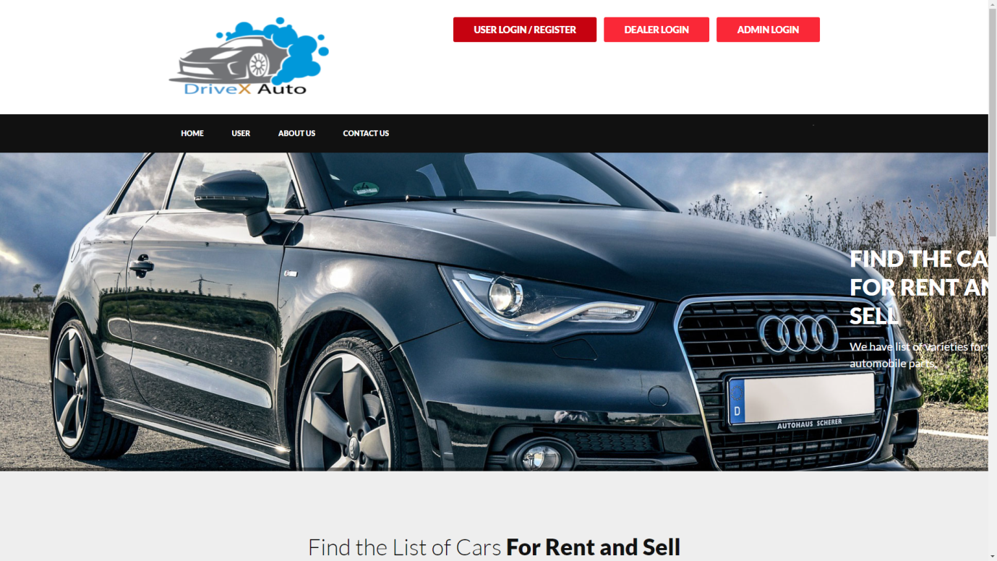

* + 1. **User Log In/ Sign In:**

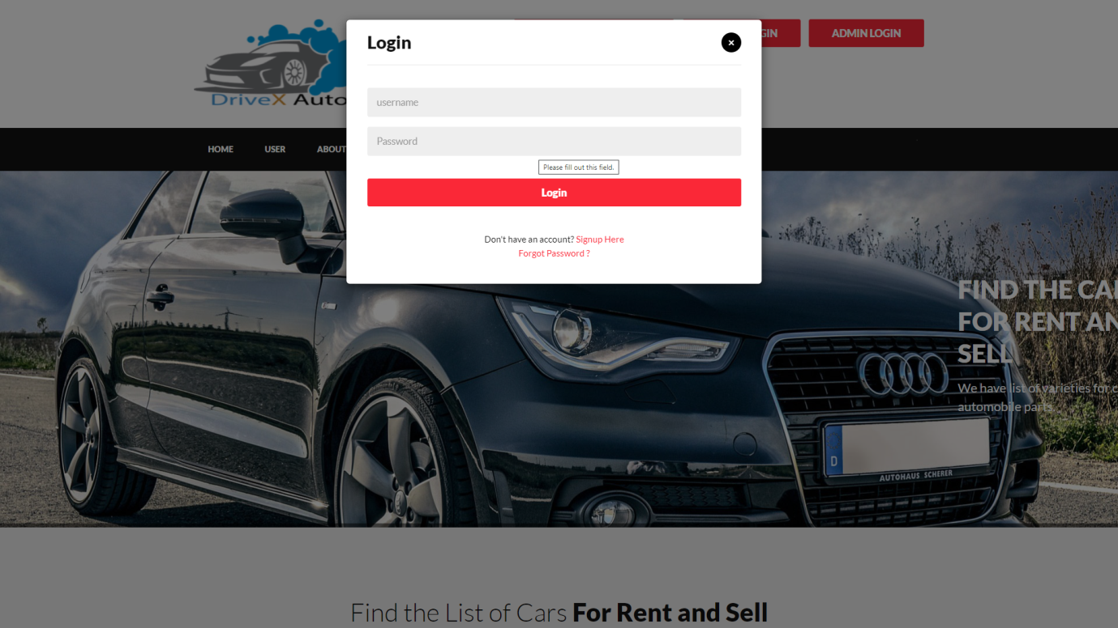

## Admin Login:

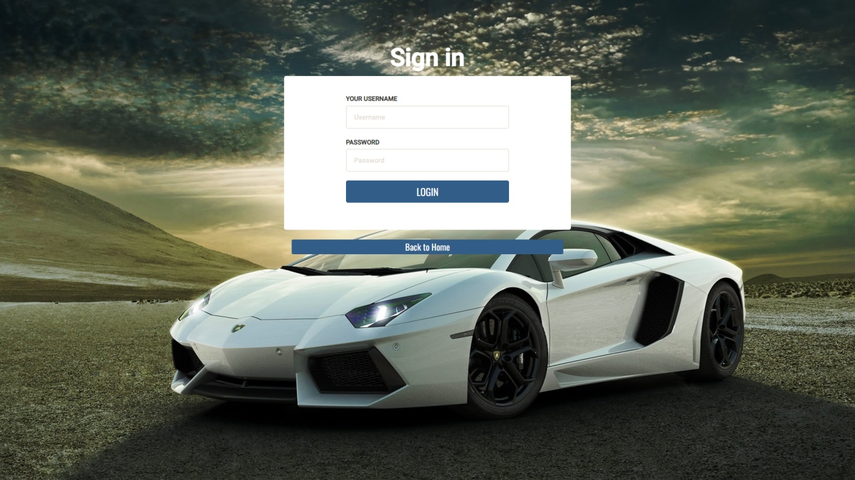

* + 1. **Admin Dashboard:**

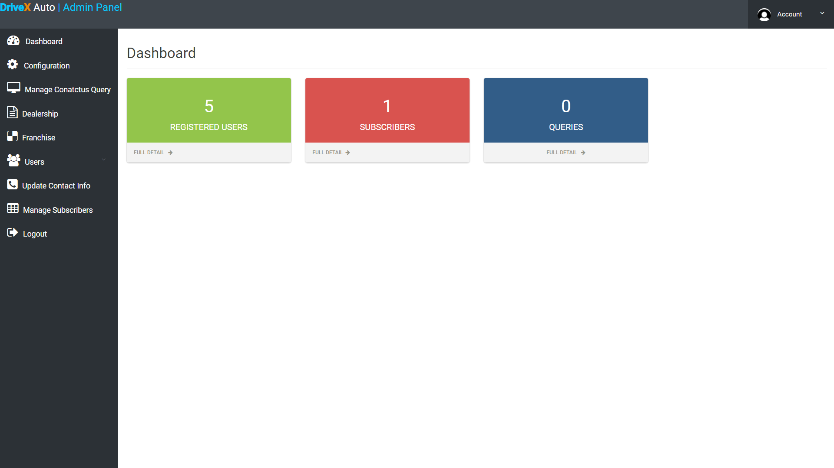

* + 1. **User Sign Up/ Create Account:**

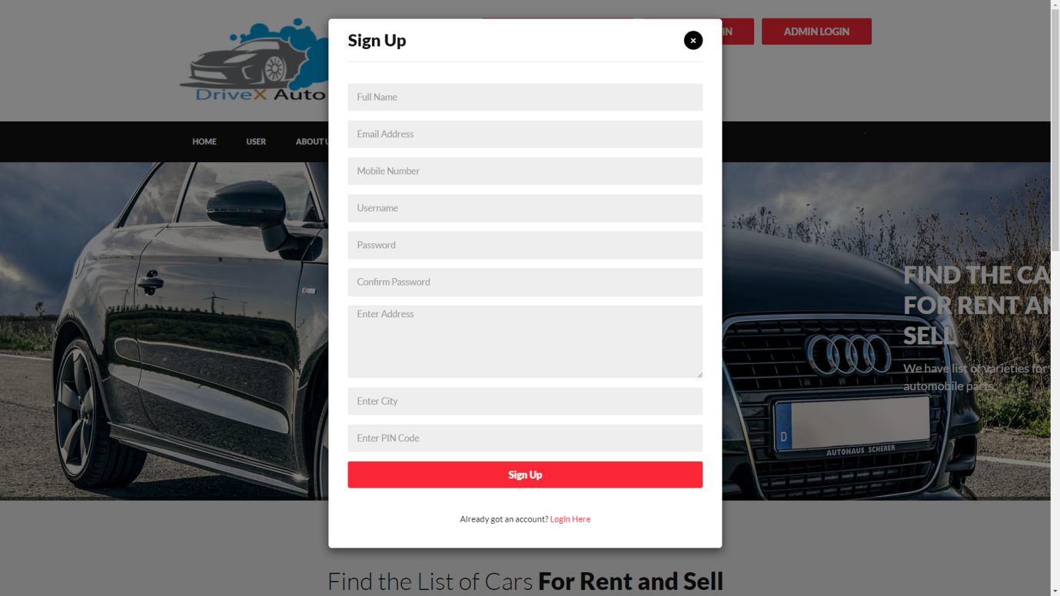

## User Dashboard:

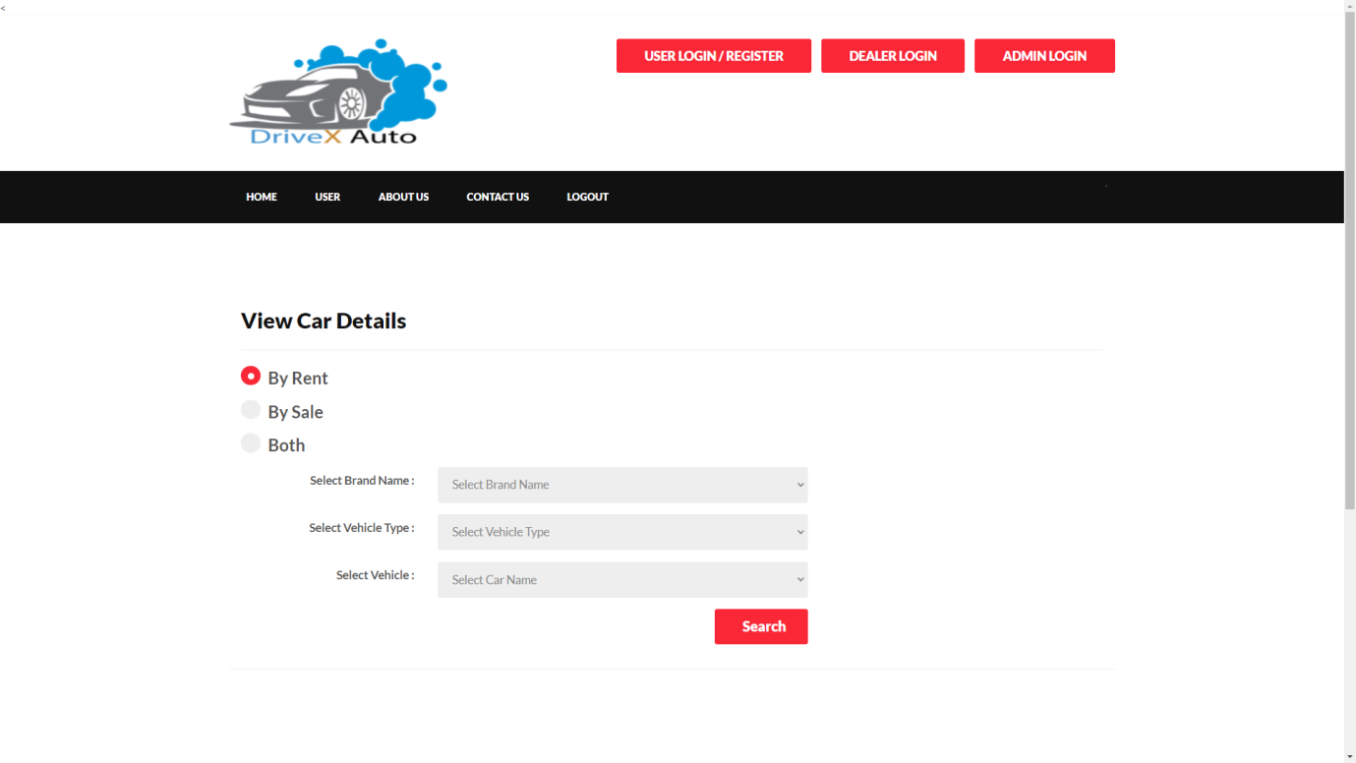

## About Us:

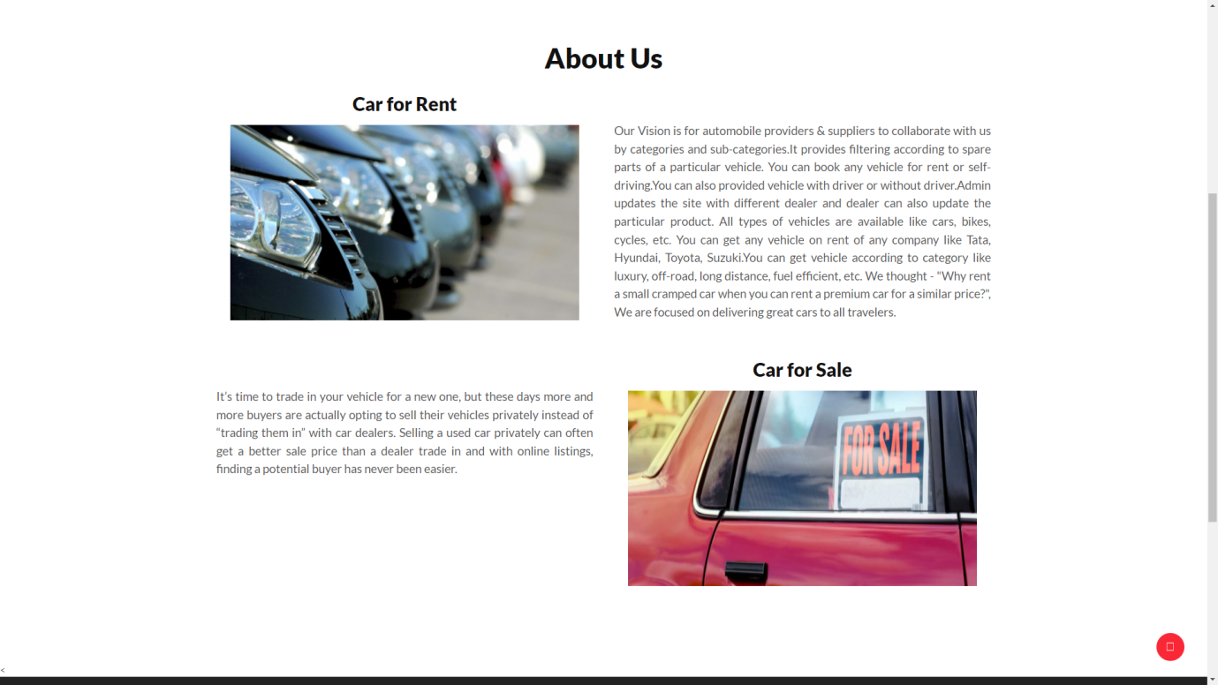

## Contect Us:

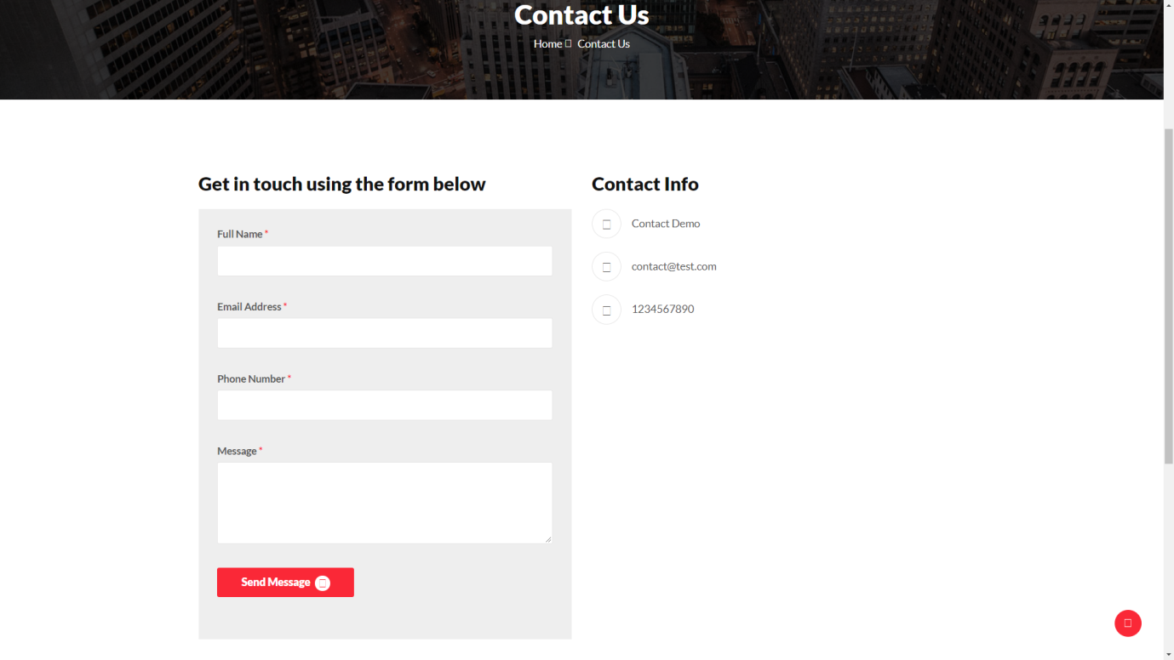

## View Brand :

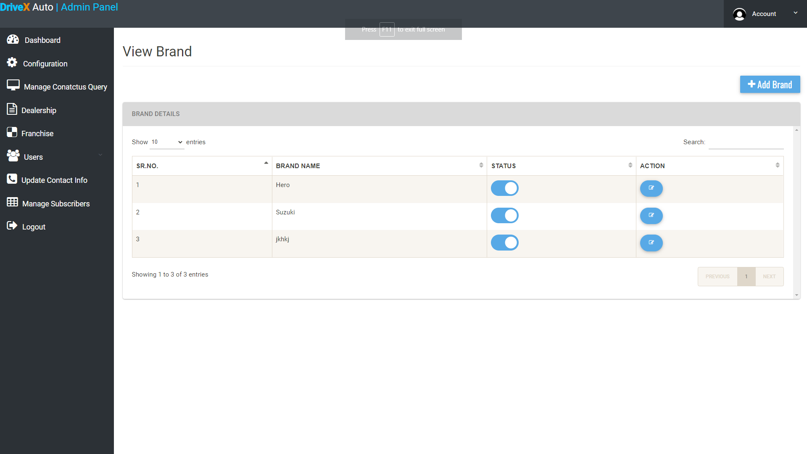

## Update Contact Info:

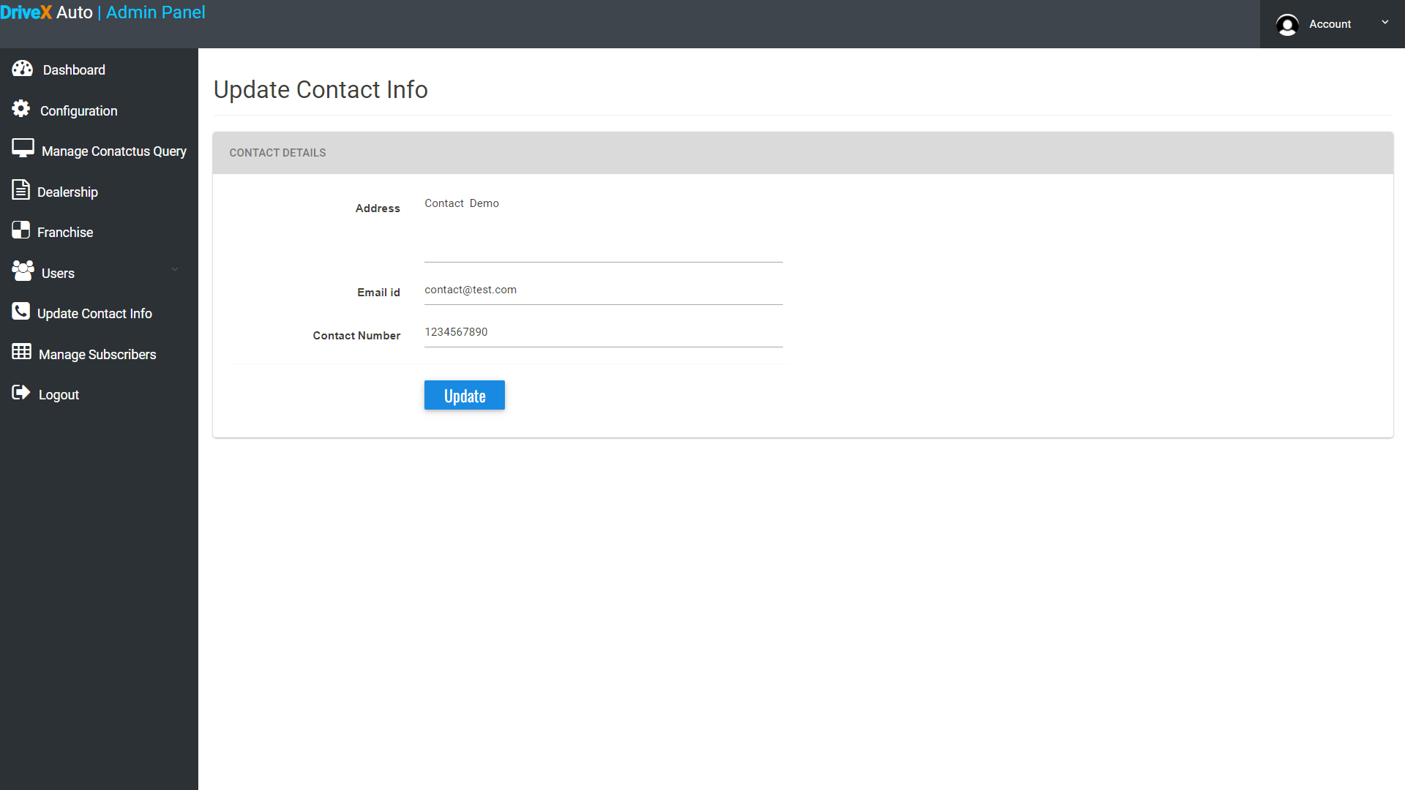

## Feedbacks :

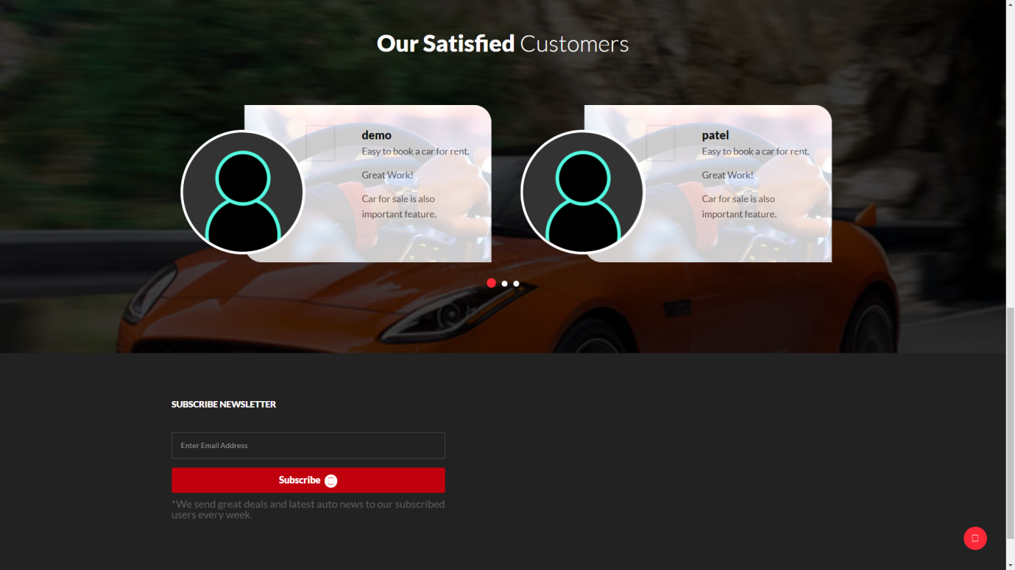

## Add Vehicle Type:

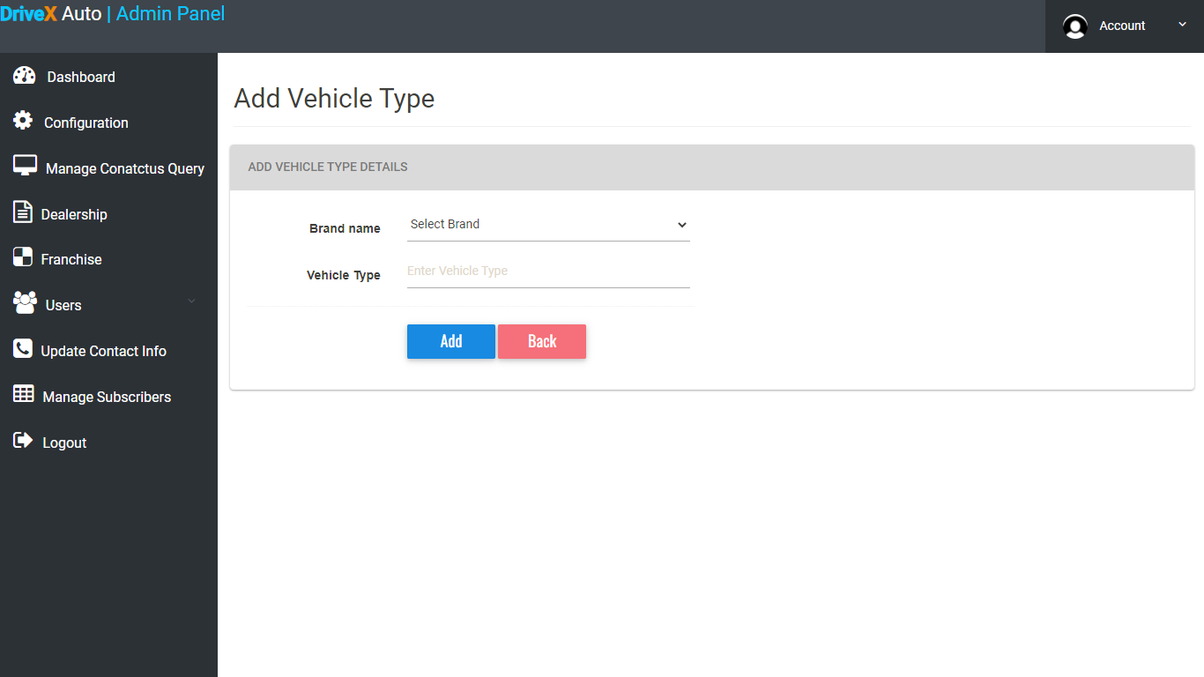

## Add Car :

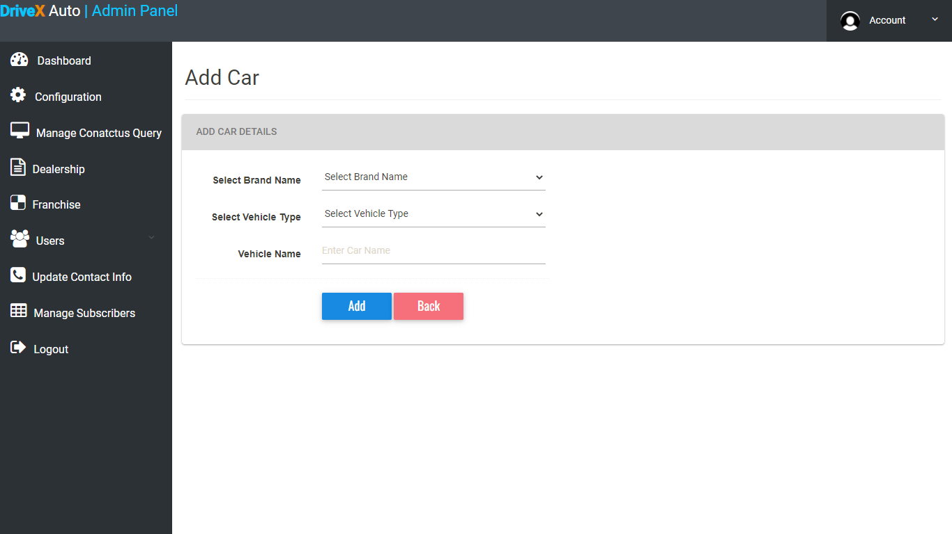

**5.3 Testing**

Testing is the process of evaluating a system or application, to check whether the application meets all requirements of the client and to detect the errors.

Generally testing can be classified into static testing and dynamic testing.

Again Dynamic Testing is classified into two types: Structural Testing (or) white box, Functional Testing (or) Black Box testing.

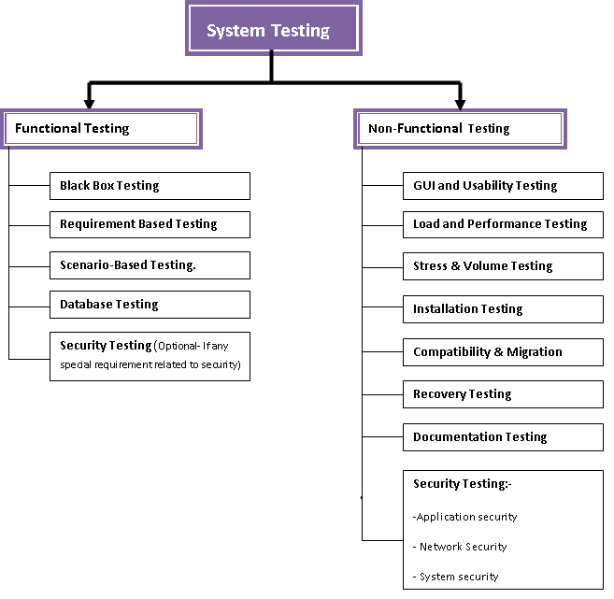

**Static Testing**

Verification activities fall into the category of Static Testing. Static testing refers to testing something that’s not running. It is examining and reviewing it. i.e., to check whether the work done meets the standards of the organization. Reviews, Inspections and Walk-through are static testing methodologies.

Example: The specification is a document and not an executing program. When we read it to find out the issues, it is considered as static testing.

1. **Dynamic Testing**

Dynamic Testing involves working with the software, giving input values and checking if the output is as expected. These are the Validation activities. Unit Tests, Integration Tests, System Tests and Acceptance Tests are few of the Dynamic Testing methodologies.

Techniques used are determined by type of testing that must be conducted.

* Functional ("black box") testing.
* Structural (usually called "white box") testing.

Black box testing involves looking at the specifications and does not require examining the code of a program. Tests that examine the observable behavior of software as evidenced by its outputs without referencing to internal functions is black box testing. It is not based on any knowledge of internal design or code and tests are based on requirements and functionality. Nowadays there are automatic code generation tools and code re-use becomes more prevalent, analysis of source code itself becomes less important and functional tests become more important.

Black box testing is easy as it is based on system’s response for a given user’s input. If we know the business functionality of the product, we can do black box testing. On the other hand, white box testing requires programming knowledge to know the internals of the code. Also it is time consuming. So only a developer can become a white box tester.

1. **Unit Testing**

Soon after the program is corrected for syntax errors, the program has to be checked for logical errors, at the unit level. Programs may have simple user inputs or outputs thru screens or reports. The inputs must be validated for their format, data type, boundary conditions etc. Also, the elementary functionality of the program must be verified. In most of the cases, the programmers themselves will do this unit testing.

If there are any problems while doing this testing, the programmerswill debug theprogram and the bugs will be fixed and will be tested again for the bug fix. It can be tested independently. Unit testing is also termed as component testing.

For example, if we need to test a java class and method, even without any screen, the programmer can test the same. Thus any piece of code, that can be independently executed, can be independently tested as well. This is termed as unit testing.

1. **Integration Testing**

When all the individual program units are tested in the unit testing phase and all units are clear of any known bugs, the interfaces between those modules will be tested, toestablish that they communicate to each other property via the specified APIs and thusthey can be integrated into an application.The integration test may be performed by the independent testers or by the development team members.

1. **System Testing**

After all the interfaces are tested between multiple modules, the whole set of software is tested to establish that all modules work together correctly as an application or system or package. This is again performed by independent testes. The testers will have to do the system testing through they are end users of the application. System testing includes special testing methods like performance testing, interoperability testing, stability testing, etc.

1. **Acceptance Testing**

After the software product is tested by the SDU in 3 different stages (unit, integration and system), the client will test it, in their place, in a near-real-time or simulated environment.

**Implementation**

This Phase will provide users with the documentation and training required to use the system effectively. Data Conversion will only occur once, but user documentation will be required. Deployment of the product will be carried out, on the hardware that is going to be used in production (on live systems). Deployment itself requires careful planning. Once the product is deployed, initial data will be populated, user training will happen.

**Release to Production and warranty Period**

When the clients to the acceptance testing and finds no problems, then they will accept the software and now they have to start using the software in their real office. It may be a real bank for a banking application. During the acceptance testing also, there may be some bug fixed done to the software. Before the software is put into production (real time environment), the SDU must release the latest versions of the software, which has no known bugs to the client.

This may be in a CD or tape or an Internet download. The clients will then install the latest software in their production system and will start using. This is called go-live process.

In the same way every product has a guarantee period software also has a warranty period. Normally it will be a 60-day or a 90-day warranty period for most kinds of software. Depending upon the complexity and size of the software the warranty period may be extended or shortened. During this warranty period, in case of any problems, the SDU has the responsibility to rectify the problem, at no charges. Again, it depends upon the contract, whether to charge for the fix or not and may vary from industry to industry.

**Strategic Approach Of Software Testing**

Testing is a set of activities that can be planned in advance and conducted systematically. For this reason a template for software testing**--**a set of steps into which we can place specific test case design techniques and testing methods**--**should be defined for the software process.

A number of software testing strategies have been proposed in the literature. All provide the software developer with a template for testing and all have the following generic characteristics:

* Testing begins at the component level and works 'outward' toward the integration of the entire computer-based system
* Different testing techniques are appropriate at different points in time(unit testing, integration testing, system testing, acceptance testing unit testing).
* Testing is conducted by the developer of the software and (for large projects) an independent test group.
* Testing and debugging are different activities, but debugging must be accommodated in any testing strategy.

A strategy for software testing must accommodate low-level tests that are necessary to verify that a small source code segment has been correctly implemented as well as high-level tests that validate major system functions against customer requirements. A strategy must provide guidance for the practitioner and a set of milestones for the manager. Because the steps of the test strategy occur at a time when dead-line pressure begins to rise, progress must be measurable and problems must surface as early as possible.

**Unit Testing**

Unit testing focuses verification effort on the smallest unit of software design-- the software component or module. Using the component-level design description as a guide, important control paths are tested to uncover errors within the boundary of the module. The relative complexity of tests and uncovered errors is limited by the constrained scope established for unit testing. The unit test is white-box oriented, and the step can be conducted in parallel for multiple components.

**Unit Test Considerations**

The module interface is tested to ensure that information properly flows into and out of the program unit under test. The local data structure is examined to ensure that data stored temporarily maintains its integrity during all steps in an algorithm's execution. Boundary conditions are tested to ensure that the module operates properly at boundaries established to limit or restrict processing. All independent paths (basis paths) through the control structure are exercised to ensure that all statements in a module have been executed at least once. And finally, all error handling paths are tested.

Tests of data flow across a module interface are required before any other test is initiated. If data do not enter and exit properly, all other tests are moot. In addition, local data structures should be exercised and the local impact on global data should be ascertained (if possible) during unit testing.

Selective testing *of* execution paths is an essential task during the unit test. Test cases should be designed to uncover errors due to erroneous computations, incorrect comparisons, and improper control flow. Basis path and loop testing are effective techniques for uncovering a broad array of path errors.

Among the more common errors in computation are:

* Misunderstood or incorrect arithmetic precedence,
* mixed mode operations,
* incorrect initialization
* precision inaccuracy
* Incorrect symbolic representation of an expression.

Test cases should uncover errors such as

* Comparison of different data types,
* incorrect logical operators or precedence,
* expectation of equality when precision error makes equality unlikely,
* incorrect comparison of variables,
* improper or no existent loop termination,
* failure to exit when divergent iteration is encountered, and
* Improperly modified loop variables.

**Test Cases**

 A **Test case**, in [software engineering](http://en.wikipedia.org/wiki/Software_engineering), is a set of conditions or variables under which a tester will determine whether an [application](http://en.wikipedia.org/wiki/Software_application), [software system](http://en.wikipedia.org/wiki/Software_system) or one of its features is working as it was originally established for it to do. The mechanism for determining whether a software program or system has passed or failed such a test is known as a [*test oracle*](http://en.wikipedia.org/wiki/Oracle_(software_testing)). In some settings, an oracle could be a [requirement](http://en.wikipedia.org/wiki/Requirement) or [use case](http://en.wikipedia.org/wiki/Use_case), while in others it could be a [heuristic](http://en.wikipedia.org/wiki/Heuristic). It may take many test cases to determine that a software program or system is considered sufficiently scrutinized to be released. Test cases are often referred to as [*test scripts*](http://en.wikipedia.org/wiki/Test_script), particularly when written - when they are usually collected into [test suites](http://en.wikipedia.org/wiki/Test_suite).

We must design tests that have the highest likelihood of finding the most errors with a minimum amount of time & effort.

Software requirements are tested using ‘Black Box’ test case design techniques.

**Black-Box** tests are used to demonstrate that:

* Software functions are operational.
* Input is properly accepted.
* Output is correctly produced.
* Integrity of external information (database) is maintained.

**White-Box** tests can be designed only after a component-level design (or source code) exists. The logical details of the program must be available. The status of the program is examined at various points to determine if the expected status corresponds with the actual status.

Internal program logic is tested using ‘White Box’ test case design techniques.

Using White-Box testing methods we can derive test cases that:

* Guarantee that all independent paths within a module have been exercised at least once.
* Execute all loops at their boundaries and within their operational bounds.
* Exercise internal data structures to ensure their validity.

Chapter-6

**Limitations and Future**

**Enhancement**

**Limitation :**

* Online payment is not available.
* Mandatory sign-up needed for the buyer.
* Only read module for viewer.
* Different rights for actors.

**Future Enhancement :**

* Payment method will be available.
* New customization in website.
* More modules will be updated.
* Bug fixes and performance.
* More attractive.

Chapter-7

Bibliography

* **Book Used :**
* Software Engineering – R.S.Pressman
* PHP For Dummies
* PHP Begineers Guide By McGrawhill Publication
* Javascript By McGrawhill Publication
* **Reference Sites:**

<https://www.tutorialspoint.com/php/>

[www.stackoverflow.com](http://www.stackoverflow.com)